STAVERTON NEIGHBOURHOOD DEVELOPMENT PLAN
Important Views
Tony Glover
SNDP Committee
Abstract
This consultation statement has been prepared to fulfil the legal obligations of the Neighbourhood Planning Regulations 2011 and provide for an audit trail as to how the Important Village Views were arrived at.
Table of Contents

Introduction ……………………………………………………………………. Page 3
Justification of Important views...…………………………. ………………… Page 4
Important Views Map ………………………………………………………… Page 7

1 Introduction

  - Populate with paragraphs in relation to document TG circulated.

Britain is blessed with an abundance of natural beauty and distinctive communities. While scenery is important to the overall quality of our communities, scenic vistas and important views are often destroyed during periods of rapid change, both in the natural and built environments. Identification and protection of these assets is an important component of natural growth and scenic stewardship.

Scenic areas endow communities with substantial benefits, such as an increased desire to move to the area and an improved feeling of community patriotism. Protecting scenic vistas and important views from the effects of haphazard development allows a community to preserve its unique charm, build civic pride, and attract positive growth to the area.

Historic views, and views of significant importance to the local area, should be maintained for the benefit of future generations, not lost forever for short term financial gain.

It is considered that to be valued, a view would need to have some form of physical attribute:
• The Important View must be demonstrably special to the local community.
• The Important View must hold a particular local significance, for example because of its beauty, historic significance, recreational use, tranquillity or richness of its wildlife.

We have endeavoured to take these attributes into account as evidence using the following reasons and justifications.

Justification of Important Views

  - The Identification and protection of these Important Views is a vital component of organic growth and historical preservation.

  - The Village of Staverton, situated in the Parish of the same name, sits in the West of the county of Northamptonshire. It’s history pre-dates the Doomsday Book and its Church sits upon the site of an eighth-century place of worship.

  - The village is located at an altitude of around 550 feet (170m) on the edge of a limestone escarpment looking westwards over the Leam Valley into the county of Warwickshire and beyond. The historic Jurassic way is part of an ancient Drovers route and passes through the centre of the village and commands spectacular views in all directions.

  - Based on the information gathered and, using Daventry District Council templates along with knowledge of the local area, the following were identified as key important views to be included within the Staverton Neighbourhood Development Plan.

  - Please see map on page 7 which show where each view is situated and the position you view it from.

View | Reason | Value
- Looking West from Public Footpath FD7 near Staverton Hall  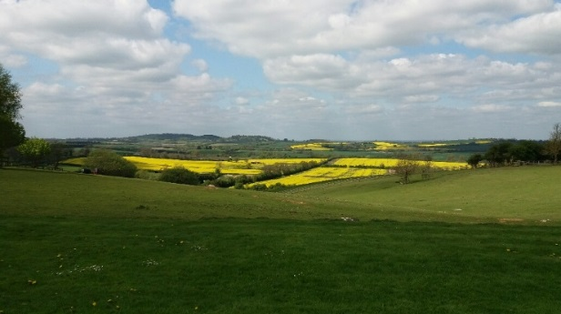  Looking across the Leam Valley  into Warwickshire and beyond | Staverton sits on the edge of a limestone escarpment, giving uninterrupted panoramic views over Rugby, Southam & Coventry, extending for over 40 miles in good conditions. (on a clear day, as far as the Malvern hills).  This view is important as it is also observed from the ‘Jurassic Way’ footpath. This footpath stretches for over 140km from Stamford to Banbury. | The footpath provides recreational facilities for many residents and visitors to the village. This in turn generates revenue for local businesses e.g. pub, farm shop etc.

View | Reason | Value
2. Looking North West from Public Footpath FD5, at the bottom of Well Lane  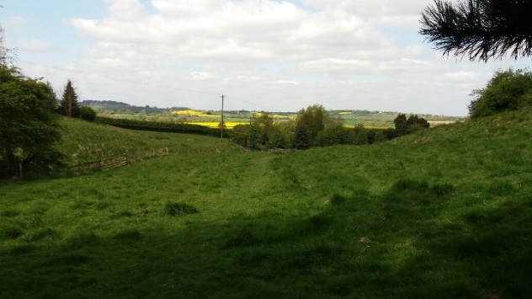  Looking down the side valley towards the Leam valley into Warwickshire | A rural side valley, leading from the village above, looking down into the Leam Valley and surrounding hills.  This is an important view as the valley extends down to the Warwickshire Leam Valley Wildlife Trust situated to the East of Leamington Spa.  The trust promotes the environmental importance of the Leam valley and surrounding areas. | Walkers and ramblers enjoy the view from the ancient pathway which is one of the last remaining Drover’s routes. Attracting visitors brings additional income to local businesses.

View | Reason | Value
- Looking North West from Public Footpath FD8, behind The Hatch  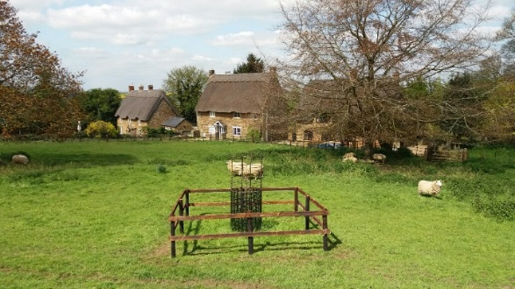  Looking over the paddock and the characterful cottages towards the rolling countryside beyond | Excellent views across the Leam valley towards the settlement of Flecknoe on the far side of the valley.  This view is important due to the elevation of Staverton. The village stands at over 170mtrs above sea level and commands unrivalled views from the limestone escarpment across | A well used publicly accessible viewing point providing locals and visitors with a historic window into Staverton past with views of early 17th century thatched farmhouse cottages.

View |  | Reason | Value
- Looking South West from Public Footpath FD12, opposite The Countryman Public House  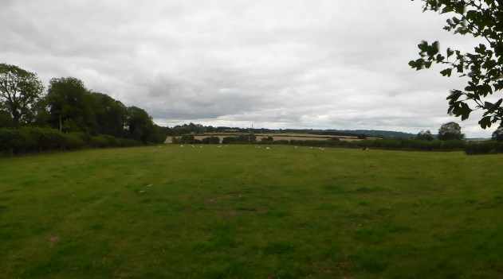  Looking towards the  Great Central Railway viaduct | The important view from the head of footpath HD12 towards the 12-arch blue brick viaduct of the Great Central railway line nearby Catesby as it crosses the infant river Leam.  First opened in 1898 as part of the Great Central’s ‘London Extension’, its construction benefited from the mechanical advantages of steam navvies.  It is an elegant and striking structure, boasting vast but gently-graded approach embankments.  From this point, locals and visitors can also see Arbury Hill. At 225 metres, this is the highest point in all of Northamptonshire. |  | Steam train enthusiasts far and wide are attracted to walk this footpath to further view this historic edifice.

View |  | Reason | Value
- Looking North West from the main A425 relief road roundabout  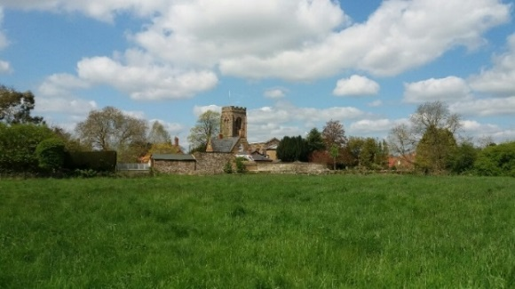  Looking towards the church | This is important as it offers excellent views of the Grade 1 listed St Mary the Virgin Church.  A place of Christian worship has stood on the site for well over a thousand years. At 170 metres, it sits at the highest altitude of any church in Northamptonshire with uninterrupted views in all directions.  The original Anglo-Saxon church was extended in the 13th century to incorporate a Norman tower. However, the graveyard dates back to the 9th century. |  | It attracts visitors worldwide thus adding to the local economy e.g. local hotels and B&B.

View | Reason | Value
- Looking East from the St Mary the Virgin church  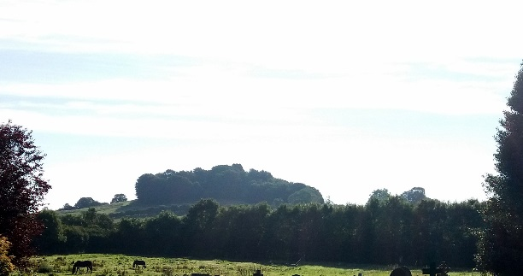  Looking towards The Clump | This view is important as it shows the nearby hill known locally as ‘The Clump’.  At an altitude of more than 700 feet, and topped with a tree lined summit, it is reliably said that if you travel East from the summit, the next land you encounter at that altitude will be the Ural Mountains in Russia. | Home to a large array of indigenous wildlife enhancing the natural environment.

3. Important Village Views Map: August 2017
