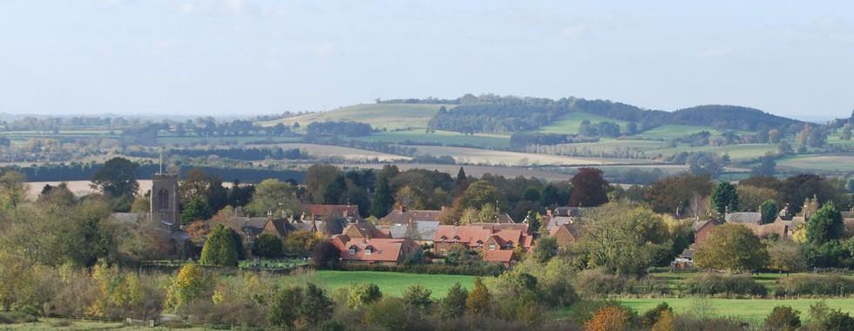
Foreword

Page 2
Section 1
Introduction & Background
Page 3
Section 2
Process summary
Page 10
Section 3
Vision, Goals & Objectives
Page 14
Section 4
Staverton – Our Village
Page 18
Section 5
Conservation area
Page 21
Section 6
Neighbourhood Development Plan
Page 26
Section 7
Policies
Page 27
Section 8
Appendix
Page 55 - 52
Page ?x

STAVERTON NEIGHBOURHOOD
DEVELOPMENT PLAN
2017-2029 version 8

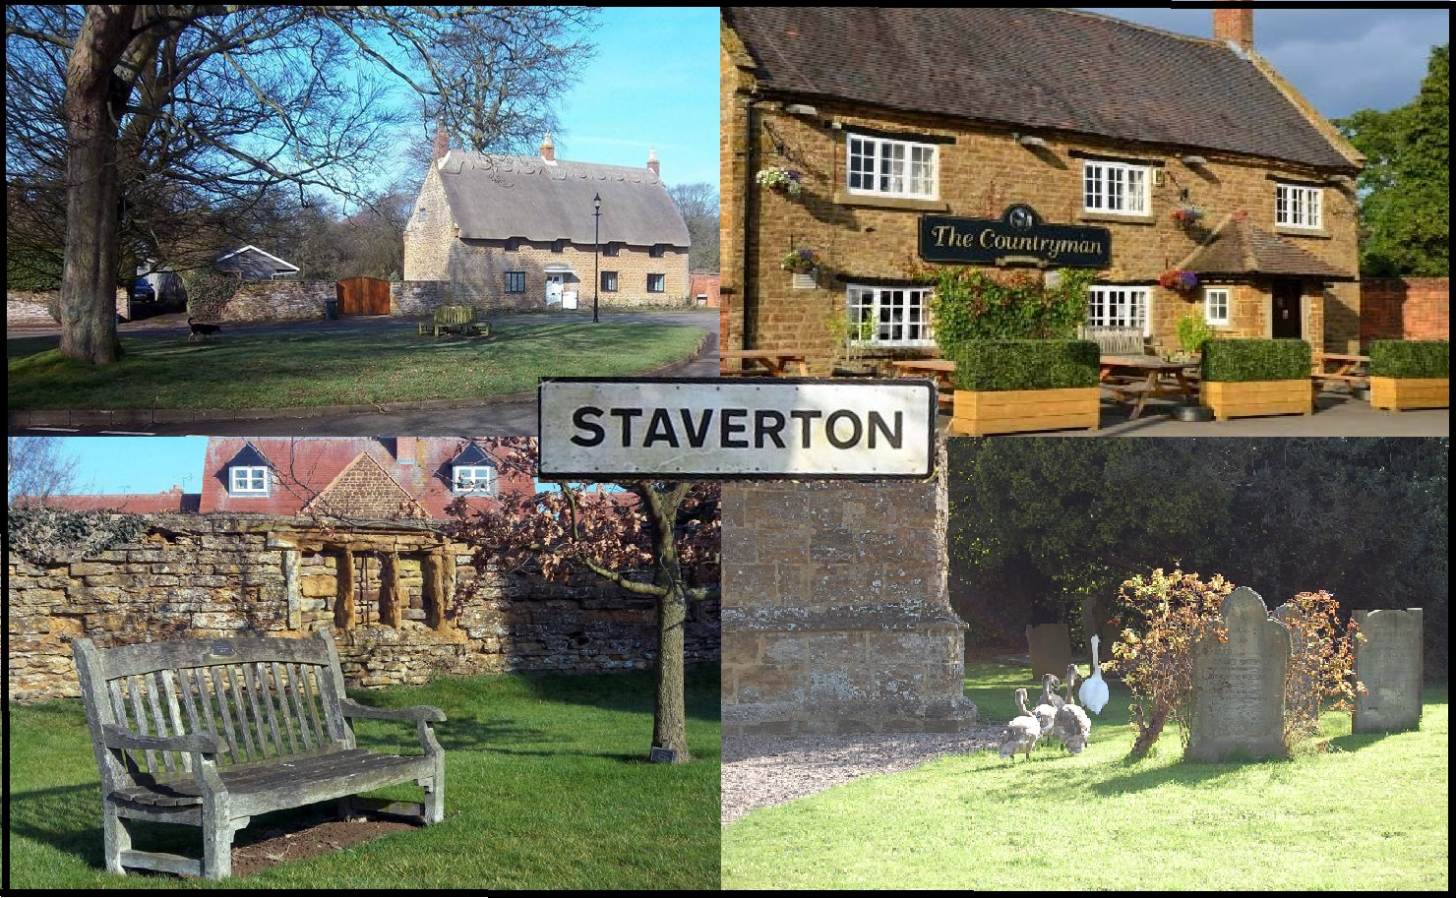

Foreword
Neighbourhood Development Plans come out of the Government’s determination to ensure local communities are closely involved in the decisions which affect them. The Staverton Neighbourhood Development Plan (SNDP) has been developed to establish a vision for the Parish and to help deliver the local community’s aspirations and needs for the plan period 2018 – 2029. Our Neighbourhood Development plan is a statutory document that will be incorporated into the Northamptonshire Planning Framework and must be used by them to determine planning policies.

Our plan has been produced by local residents, with the support of a SNDP committee, using the views of the residents of Staverton Parish. The SNDP committee has consulted and listened to the community, local businesses and organisations on a wide range of issues that will influence the wellbeing, sustainability and long term preservation of our rural community. Every effort has been made to ensure the views and policies contained in this document reflect those of the majority of residents in Staverton Parish.

A Neighbourhood Development Plan has many benefits. The SNDP has been developed to:-

- Protect the village from uncontrolled, large scale, or poorly placed development and
- Ensure that any development is sympathetic to, and retains the look and feel of the village

The committee received 145 separate responses to the questionnaire undertaken. In total the responses contained approx. 500 comments from residents and businesses. The comments were reviewed by the committee. A full list of these comments can be found in the Parish Questionnaire Statement.

An electronic copy of this plan, the Consultation Report, and suite of supporting documents can be found online at www.stavertonparish.com

The Parish Council would like to thank the members of the committee and pay tribute to their work since June 2015. The Parish Council is also grateful for the help and engagement of many others in the village without which it would not have been possible to produce this SNDP.

Tony Glover
Chair, Staverton Parish Council

