---------------------------------------------------------------------------------------------------------------------------------------
Section 1 – Introduction and Background
-----------------------------------------------------------------------------------------------------------------------------

Introduction

  - The Localism Act 2011 introduced new statutory rights whereby communities were given powers through the development of Neighbourhood Plans, to shape future development in their area. The intention behind this act was to give communities more of a say in the development of their local Parish (within certain limits and parameters). Decision making on future development within that Designated Neighbourhood Area (DNA) was passed down from Local Government to local Communities.

  - Six years on from the passing of this Act, lessons have been learnt by both Government and early adopters. The Government consulted in early 2016 on technical changes to the Neighbourhood Planning process. The Housing and Planning Act 2016 followed, and the changes will be brought in via secondary legislation. This is designed to enable plans to progress in a more efficient and supported manner.

Purpose

  - The purpose of the SNDP is to ensure that the Parishioners of Staverton have the opportunity to influence what, where and how future development should take place within our Designated Neighbourhood Area.

  - This has been achieved by firstly setting out a Vision for our Area, which was agreed by Parishioners. The Vision was then split into its constituent parts to derive Core Objectives, which were then further broken down into underpinning Goals. The Goals were translated into a practical set of Policies, that seek to directly influence any future development within the Designated Neighbourhood Area. Policies have all been heavily influenced by data derived from the Questionnaire, delivered to every household in the Parish. The Process as described, is fully explained in Section 2 of this plan.

  - When adopted the SNDP will become part of the development plan within the West Northamptonshire Joint Core Strategy and the saved policies of the Daventry District Council local plan, and will form part of the Daventry Local Plan. The policies and proposal contained within it, will be used in the determination of new planning applications, and appeals by the Local Planning Authority. Consequently, unless material considerations indicate otherwise, decisions on whether or not to grant planning permission in the Designated Neighbourhood Area will need to be made in accordance with the Neighbourhood Plan.

What is a Neighbourhood Plan?

  - The SNDP is a tool by which our Community can develop a local Planning Framework for guiding the future development, enhancement of existing assets, and conservation within our Parish. It contains community led Policies derived from a programme of community engagement, thus ensuring that the views, aspirations, wants and needs of Parishioners are formally represented. It will inform where future development should be located and the size and pace of any such development along with the policies contained within this plan.

How will it work?

  - The SNDP has been developed following a process laid down by Government. This process must include two six week periods of consultation on the draft plan, and culminate in a referendum.
  - If 50% of those voting in the referendum vote ‘Yes’, then Daventry District Council are required to formally adopt the plan. They will be obliged by law to be guided by it when considering future development in the area. If there is a majority ‘No’ vote, then the council will take no further action. The Parish Council would need to decide whether to investigate the reason/s behind a majority ‘No’ vote and potentially opt for redrafting the plan accordingly.
  - There are five key stages to Neighbourhood Development Planning as follows:-

Stage 1: Defining the Designated Neighbourhood Area
Stage 2: Preparing the plan
Stage 3: Consultation
Stage 4: Pre-Submission Consultation
Stage 5: Examination
Stage 6: Referendum
Stage 7: Making a Neighbourhood Plan
  - These stages are covered in detail within Section 2 of this plan.

Qualifying body

  - Staverton Parish Council (SPC) are the Submitting body for this Neighbourhood Development Plan. The Research, Public Consultations and Plan writing were undertaken initially by a working group, then by a committee of the Parish Council, namely SNDP committee and completed by the Parish Council. The group/committee comprised of Parish Councillors and Volunteers from within the Parish. The composition of the group has changed over time. A full list of past and present members is listed in Appendix 1.

Neighbourhood area

  - As the qualifying body, Staverton Parish Council approached Daventry District Council (DDC) to designate the Designated Neighbourhood Area in 2015. The application was submitted in May 2015, and following consultation on the application Daventry District Council designated Staverton Parish as a Neighbourhood Area in June 2015. The Staverton Parish Designated Neighbourhood Area is shown on Map 1.

Map 1 - Staverton Parish Designated Neighbourhood Area

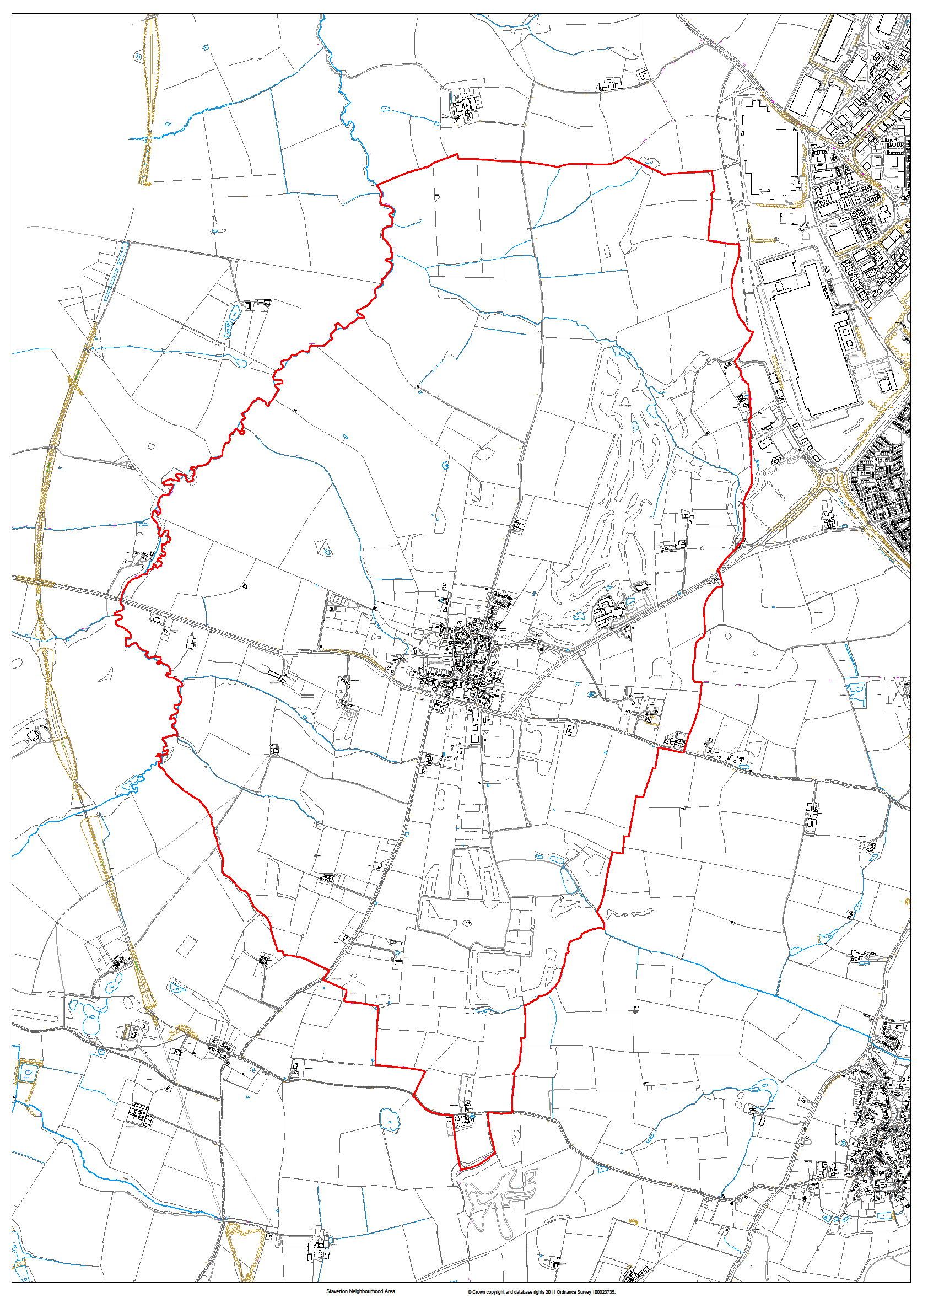
Staverton Neighbourhood Area: Crown copyright and database rights 2011 Ordnance Survey 100023735.

Neighbourhood area

  - The SNDP must meet certain ‘basic conditions’. These must:-

- Having a regard to national policies and advice contained in guidance issued by the Secretary of State it is appropriate to make the Neighbourhood Plan
- “The Making” of the Neighbourhood Plan contributes to the achievement of sustainable development
- ‘The Making’ of the Neighbourhood Plan is in general conformity with strategic policies contained in the development plan for the area of the authority (or any part of that area)
- ‘The Making” of the Neighbourhood Plan does not breach, and is otherwise compatible with EU obligations
- Prescribed conditions are met in relation to the Neighbourhood Plan and prescribed matters have been compiled with in connection with the proposal for the Neighbourhood Plan

  - Adherence to these conditions ensures that an appropriate balance is struck between a community influencing future development within their Designated Neighbourhood Area by developing a Neighbourhood Development Plan, whilst ensuring it does not inappropriately constrain the delivery of important strategic policies for the local area.

National Policies

  - At a National level the SNDP has taken into account relevant policies contained in the National Planning Policy Framework (NPPF), and the National Planning Policy Guidance (NPPG).

Local Policies

  - Staverton Parish is situated within the administrative area of Daventry District Council. In turn Daventry District Council sits within the County of Northamptonshire, which is administered by Northampton County Council (NCC). Northampton County Council are responsible for setting County wide policies, and Daventry District Council is responsible for determining local policies. In developing the SNDP reference has therefore been made to the West Northamptonshire Joint Core Strategy, and the Saved Policies within the Daventry District Council Local Plan (1997), due to be replaced by policies within the emerging Daventry Settlements and Countryside Local Plan.

Sustainable Development

  - The Government’s approach to Sustainable Development is set out in the National Planning Policy Framework. The SNDP contributes to the achievement of Sustainable Development through policies that advocate the following:-

- Provision of a mix of housing types, based on meeting local need
- Support for high quality build design
- Appropriate transport provision, including accessible public transport, cycle facilities and safe and convenient pedestrian routes
- Upgrading of infrastructure to support and encourage home working
- Support for ‘green’ development that incorporates facilities to encourage recycling, water collection, local energy generation, etc.
- Retention and/or enhancement of valued Community assets
- Protection and enhancement of wildlife areas, open green spaces, Conservation Area, Special Landscape Areas, and measures to support bio-diversity
- Conservation of historic buildings and environments

European Union Obligation

  - The plan was considered as part of an assessment of compliance with the basic conditions, and the plan was found to conform to the appropriate European Union Obligations.

  - The Strategic and Environmental Assessment and Habitats and Species Regulations 2010 have also been complied with.

Human Rights requirements & Equality

  - The plan was considered as part of an assessment of compliance with the basic conditions, and the plan was found to conform to the appropriate Human Rights requirements and the Staverton Equality and Diversity statement.

Plan period, monitoring and review

  - The period covered by the SNDP is from 2017 up to 2029. This is in line with the plan period for the West Northamptonshire Joint Core Strategy, and the emerging Settlements and Countryside Local Plan. This enables the SNDP to be in general conformity with the policies and time period stated within this plan. It therefore sets out our housing development requirements for the period up to 2029.

