----------------------------------------------------------------------------------------------------------------------------------------
Section 3 – Vision, Goals & Objectives
-----------------------------------------------------------------------------------------------------------------------------

Consultation

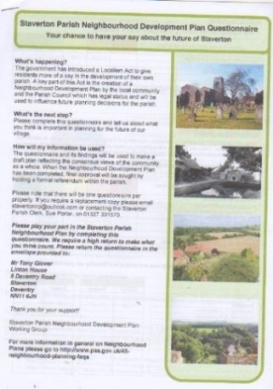
  - The Vision Statement and Objectives were developed with the local community by way of data from the questionnaire, and subsequent consultation
events.
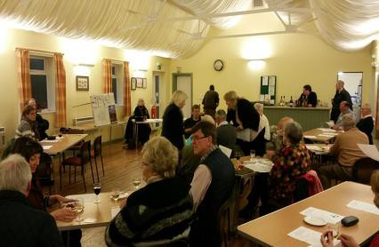
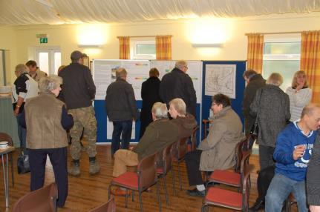

  - The overwhelming view from Parishioners is that Staverton’s strength is that it is a small rural village, which should retain its character. The Parishioners are not against small scale change in order to remain sustainable.

Vision Statement

  - What gives Staverton its character? - “That it is a small traditional rural village surrounded by agricultural land and other small villages with a strong community spirit”

  - The above information was brought together into a vision statement that reflects all elements:

‘A sustainable cohesive community that retains its character,

rural surroundings and green spaces, whilst embracing the

positive benefits appropriate development can bring’

3.5 The Vision statement was presented to Parishioners at a consultation event where it was supported.

Objectives & Goals

3.6 The objectives were derived from the Vision Statement and broken down into three Core Objectives:

    - Sustainable Community
    - Protection of the Environment
    - Management of change for the positive benefit (Sustainable development)

  - Underpinning these three Core Objectives a number of key objectives and goals were defined: as detailed in the Parish Questionnaire Statement on the Parish Website www.stavertonparish.com/councils/staverton-neighbourhood-development-plan/.
Core Objective (1) - Sustainable Community
Main comments raised by local people during the consultation process

    - To provide for some smaller homes & bungalows within Staverton village
    - New homes to be distributed over several small sites
    - Sites would be chosen to facilitate social integration into Staverton village
    - To provide for up to ten new dwellings on a site
GOAL(1) – To provide housing that meets the need of the local community
KEY OBJECTIVE:  - To support small scale housing development that meets identified local needs  - To provide for a mix of housing types including smaller homes, particularly for elderly villagers wishing to move to a more suitable home within Staverton | SUPPORTING POLICIES: West Northants Joint Core Strategy  R1  HS22
GOAL (2) – To protect community cohesion within the village
KEY OBJECTIVE:  - To provide for moderate housing growth  - That any development is sited to fully integrate into Staverton village  - To provide for organic growth within Staverton village  - That each new development is suitably small in scale  - That size, mix and type of new build is suitable with respect to it`s location  - To reject large scale developments that could adversely affect the strong sense of community within the village | SUPPORTING POLICIES: West Northants Joint Core Strategy  R1 Daventry Local Plan HS22
GOAL (3) – To encourage preferential access to new homes for people with a strong local connection
KEY OBJECTIVE:  - To recognise that changing demographics require a corresponding re-balance of suitable homes in Staverton  - To provide for a balanced mix of new housing corresponding to need  - To provide for a balanced mix of tenure corresponding to need  - Provide for accessibility to homes for all sectors of a balanced and inclusive community | SUPPORTING POLICIES:  National Planning Policy Framework
Goal (4) - To retain existing valued amenities
KEY OBJECTIVE:  - To support the provision of continued access to local community services  and facilities (including educational, public transport, utilities and amenities)  - To support the capacity of those public services in line with growth from  new housing.  - To resist any proposed loss of valued amenities resulting from any proposed new development | SUPPORTING POLICIES:  HS22  GN2 (a)
Goal (5) - To support the provision of mobile and broadband provision for the benefit of the community
KEY OBJECTIVE:  - To ensure that all financial contributions received by Staverton Parish Council from developments (S106 and/or CIL) are used on projects and initiatives that meet the identified needs of the community. | SUPPORTING POLICIES:  GN2 (p)

Core Objective (2) – Protection of the Environment
Main comments raised by local people during the consultation process

- To prioritise the wellbeing of the natural environment in decision making
- To protect existing and encourage the creation of new local wildlife habitats
- To take every opportunity to safeguard the rural environment
- To value and protect all public open spaces in Staverton
- To see that any new development is built to high ecological standards
- To value and protect our natural and built inheritance throughout Staverton Parish

GOAL (6) – To retain the rural character and cohesive nature of the village
KEY OBJECTIVE:  - That any new development integrates into Staverton by design  - That design properly reflects the distinctive character of Staverton  - To support the use of only high quality building materials eg stone or brick  - There be provision for mixed developments of up to10 new homes on a site  - That each home reflects the character and feel of the immediate locality  - To support the provision of open green spaces in any new development | SUPPORTING POLICIES:  West Northants Joint Core Strategy  S1  R1  HS22  EN1  EN18  EM13  GN1 (e)
GOAL (7) – To have a friendly and safe environment
KEY OBJECTIVE:  - To maintain the existing low crime, secure and peaceful environment  - To support the integration of new housing into the existing community  - To provide for improved management of intrusive traffic on the A425  - To support reduced speed limits on the A425 throughout Staverton Parish | SUPPORTING POLICIES:  National Planning Policy Framework
GOAL (8) – To retain the open spaces in the village
KEY OBJECTIVE:  - To preserve green spaces within the village  - To protect and enhance Staverton’s open spaces e.g. Village Green  - To support the provision of green space within any new development | SUPPORTING POLICIES:  HS22  EN1
GOAL (9) – To preserve the special landscape area
KEY OBJECTIVE:  - To protect, enhance and conserve the surrounding countryside, special landscape area and important views.  - To protect and enhance the historic environment of Staverton  - To ensure any new development respects Staverton`s Special Landscape Area status. | SUPPORTING POLICIES:  HS22  EN1  EM13

Core Objective (3) – Management of change for the positive benefit (Sustainable development)
Main comments raised by local people during the consultation process

- To support the provision of high quality IT services throughout Staverton Parish
- To provide for access to training and services
- To spend or invest any Community Infrastructure Levy for the benefit of the community.
- To reflect the changing demographic in Staverton in the provision of suitable housing development
- To ensure the designated area status of Staverton

GOAL (10) – To influence development for positive benefit
KEY OBJECTIVE:  - To support the provision of recreational, play areas and facilities for children.  - To support the protection and preservation of existing bridle paths, public footpaths and high quality agricultural land in the Parish.  - To encourage support for existing village amenities e.g. Village Hall, St Mary The Virgin Church, Playing fields, and all green spaces  - That open land that is important to the character and form of the village remains protected  - To provide only for development sites of up to ten dwellings that will integrate into Staverton village | SUPPORTING POLICIES:  West Northants Joint Core Strategy  R1  DDaventry Local Plan  HS22  EN1  GN2 (a)
GOAL (11) – To ensure that the appropriate infrastructure is in place to support the existing and future needs of the Village
KEY OBJECTIVE:  - That utilities and service providers address existing local issues in advance of any new development. (currently the sewage system)  - That traffic flow in Staverton is integral in the design of any new development  - That all new development has provision for high speed broadband  - That good lighting, dog bins, waste bins are provided on any new housing development  - To positively support the development of improved mobile communications  - That enough off road parking for all residents is provided in every new housing development.  - To promote usage of our regular bus services | SUPPORTING POLICIES:  GN2 (d)
GOAL (12) – To minimise the impact of any new development on the environment
KEY OBJECTIVE:  - To support the protection of mature native trees and hedges  - To support the development of Eco friendly housing  - To support the reduction of the carbon footprint of the village  - To support change to parking arrangements in Staverton that benefit the  community | SUPPORTING POLICIES:  HS22  EN1  GN1 (b)

