----------------------------------------------------------------------------------------------------------------------------------------
Section 5 – Conservation Area
--------------------------------------------------------------------------------------------------------------------------
Saverton village setting

5.1 Following a Landscape Character Assessment, for the West Northamptonshire Joint Core Strategy, Staverton Parish was placed into the category of ‘Staverton Hills’ with elevations of over 500ft above sea level. The rolling land to the west descends to, and looks out over the plains of Warwickshire, making this one of the most attractive views in Northamptonshire.

5.2 In addition, parts of this landscape, namely, Staverton Parish was designated a ‘Special Landscape Area’ by Daventry District Council in date which placed a responsibility on all to protect and enhance its special qualities

5.3 The Daventry Masterplan 2040 places an approximately 650 metre wide belt of land stretching from close to the A361 as land with “inaccessible gradients”.
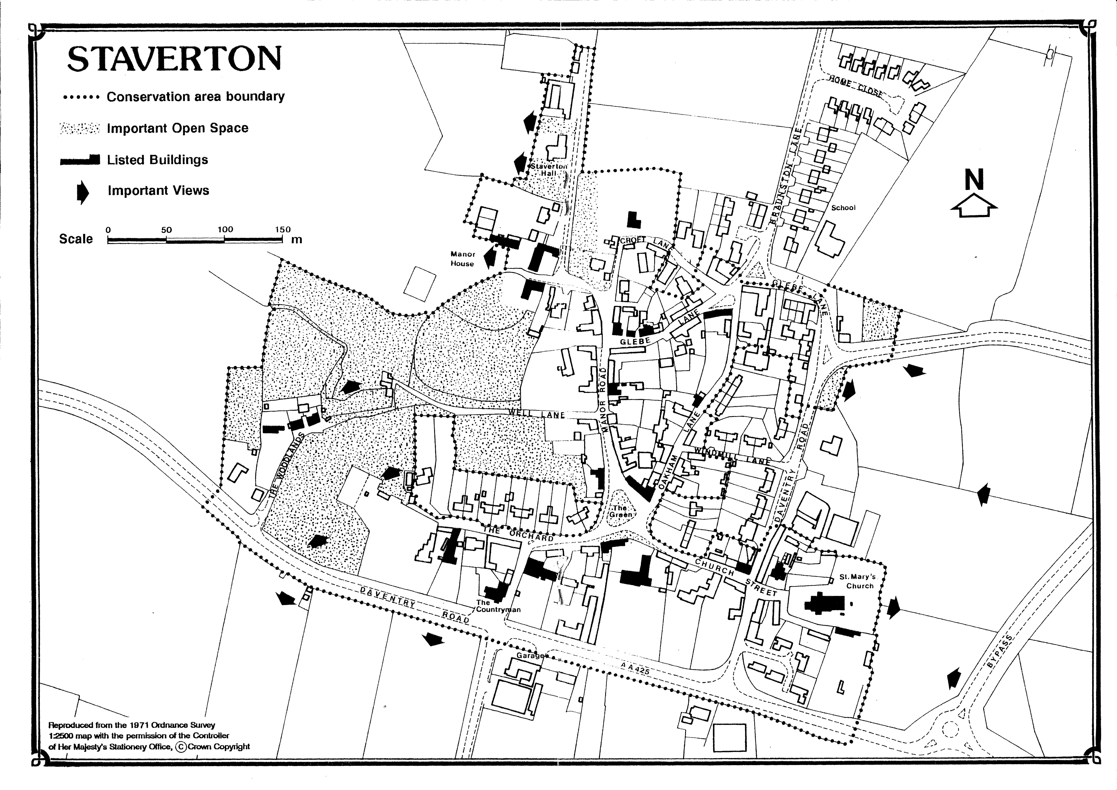
Built Environment
5.4 The village Conservation Area was designated in 1990. Within the conservation area are 27 listed buildings that have been judged to be of architectural or historic interest. Map 3 below details the conservation area as designated in 1990: Map 4 details an early 1884 edition of Ordinance Survey map showing the old village.
Map 3 – Conservation Area

Map 4 – 1884 Ordnance Survey Map

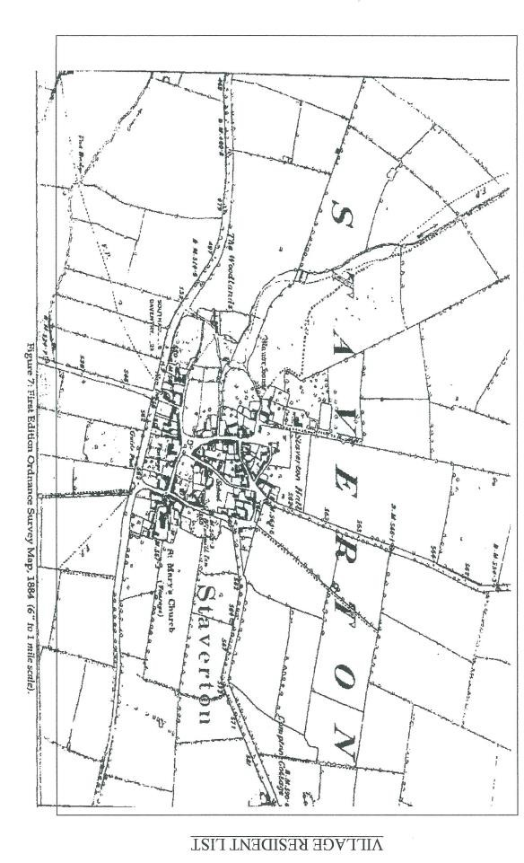

Open Spaces, Village Green & Landmarks
5.5 The village green is the most significant green
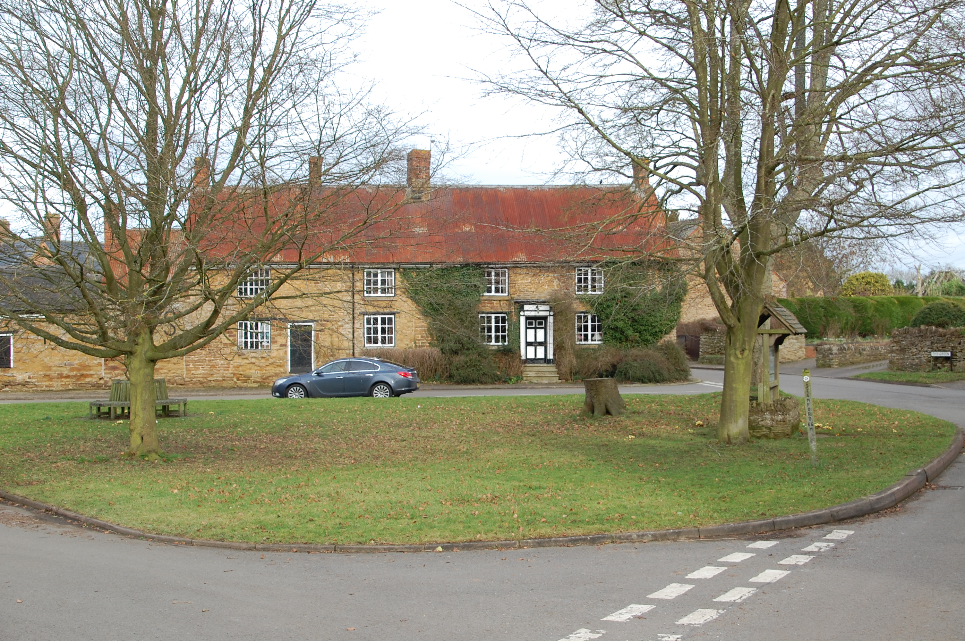
space in the centre of the conservation area. The limited open space in the village gives a sense of enclosure and identity. The Open spaces/views statement details the village greens, pocket park and playing field all of which form an important green space near the periphery of the village.

5.6 St Mary The Virgin 13th century church is dominant at the edge of the village. Its Norman tower is a landmark to the south east. The churchyard contains listed tombs and graves, and there is a war memorial in the Church.

5.7 The Countryman public house is a landmark on the south side of the village.
Buildings

5.8 The conservation area contains a wide range of buildings from medieval to modern. Most buildings are two storey with rooflines of varying pitches and heights which adds to the historic character of the village. The roofs, many of which used to be thatch are now mostly tiled. Some of the houses, as well as the church and a number of features in the churchyard are listed. The older buildings generally open onto the street. Most of the properties built after 1918 are built further back creating front gardens. The village buildings are now predominantly residential, the centrally placed shop and the post office having closed down. Some other businesses, including farm shop and garage are located on the western edge of the village.

5.9 The traditional and historically important buildings and stone boundary walls, form the core elements in the conservation area and reflect the general vernacular style of building in this part of Northamptonshire.
Conservation Status

5.10 Section 69 of the 1990 Listed Buildings and Conservation Areas Act, imposed a duty on local planning authorities to designate as a Conservation Area any “areas of special architectural or historic interest, the character or appearance of which it is desirable to preserve or enhance.” Conservation Areas also have special interest which warrant particular protection from inappropriate development, and require a high regard to be given towards the preservation or enhancement of their overall character. Government guidance for conservation areas aims to harmonise any new development with its neighbours and to take full advantage of “group value” (the inter relationship of buildings in close proximity). Thus development and other land use changes which fail to preserve or enhance the character of the Conservation Area should be resisted.

5.11 Conservation Area Status does not prevent future development, but provides greater control over development and protection of trees. Development proposals in or near a conservation area would be required to pay special attention to the desirability of preserving or enhancing the character or appearance of the conservation area, within its rural setting. Any proposals, which would harm the appearance or character of the conservation area, and which would harm the community cohesion should not be approved. In order to avoid harm to the conservation area, any development proposal will need to:

    - Respect the character or appearance of the locality by reason of their scale and proportion
    - Meet the needs of the community
    - Have regard to the historic interest and/or architectural detailing of existing buildings
    - Utilise materials appropriate to the locality and avoid the use of non- traditional materials unless they are a suitable alternative or would not detract from the overall appearance of the locality
    - Safeguard trees of amenity value, traditional hedgerows and historic boundary stone walls

5.12 The above sets out clear and simple guidance for the design of all development in the village, based on its character, its conservation status, and its harmony within its setting, and whether it makes a positive contribution to the immediate environment.

5.13 The nature of the development in the conservation area creates a high degree of enclosure and identity within the village. Views out from the centre are restricted, which serves to promote the feeling of enclosure and identity. The combination of historic buildings, group value, open space and mature landscaping is considered worthy of protection and have been reviewed as part of the production of this plan.

