-----------------------------------------------------------------------------------------------------------------------------------------
Section 7 – Policies
-----------------------------------------------------------------------------------------------------------------------------

7.1 Staverton Parish Council is preparing a Neighbourhood Development Plan for the Designated Neighbourhood Area under the provision of the Localism Act 2011 and the Neighbourhood Planning (General) Regulations 2012.

7.2 The Designated Neighbourhood Area covered by the SNDP is shown in Map 1 page 7.

7.3 Neighbourhood plans provide local communities with the chance to shape the future development of their area. Once approved at referendum the Plan becomes a statutory part of the SNDP for the Designated Neighbourhood Area and will carry significant weight in how planning applications are decided.

Plans must meet five basic conditions: These are:

- Having a regard to national policies and advice contained in guidance issued by the Secretary of State it is appropriate to make the Neighbourhood Plan
- “The Making” of the Neighbourhood Plan contributes to the achievement of sustainable development
- ‘The Making’ of the Neighbourhood Plan is in general conformity with strategic policies contained in the development plan for the area of the authority (or any part of that area)
- ‘The Making” of the Neighbourhood Plan does not breach, and is otherwise compatible with EU obligations
- Prescribed conditions are met in relation to the Neighbourhood Plan and prescribed matters have been compiled with in connection with the proposal for the Neighbourhood Plan

7.4 In addition, the SNDP must be able to show that it has properly consulted local people and other relevant organisations during the process of making the plan and has followed regulations (see our consultation statement).

7.5 This section sets out the planning policies to guide development in Staverton up to 2029. The vision for Staverton developed in this plan is to have:

‘A sustainable cohesive community that retains its character, rural surroundings and green spaces, whilst embracing the positive benefits appropriate development can bring’

7.6 To deliver the vision three Core objectives have emerged which are supported by key objectives, and goals:

Core Objective (1) Sustainable Community
Core Objective (2) Protection of the Environment
Core Objective (3) Management of change for the positive benefit (Sustainable development)

7.7 The policies and proposals contained within this plan have been divided into the above three core objectives. They should be read in conjunction with the relevant design policies of Daventry District Council and West Northamptonshire Joint Core Strategy.

Table 1 – Policies
CORE OBJECTIVE | REF | POLICY
- To promote a Sustainable Community | SC1 | Protection and Enhancement of Local Community Assets & Recreational Facilities policy
 | SC2 | Housing (inclusive of affordable housing and local connection) policy
 | SC3 | Access (inclusive of footpaths, cycle ways, bridal ways & connectivity) policy
- Protection of the Environment | PE1 | Protecting and enhancing the landscape and character policy
 | PE2 | Open/Green Spaces policy
- Management of change for the positive benefit | MC1 | Development Policy
 | MC2 | Development Design Policy
 | MC3 | Infrastructure Policy

7.8 Each policy has a Policy Background & Summary which provides an explanation of the policy and what it is seeking to achieve.

7.9 The policies are presented within pink boxes in this document. It is against these policies that all planning applications will be assessed.

SC 1 Protection and Enhancement of Local Community Assets and Recreational Facilities policy

7.10 Policy Background and Summary
For a village such as Staverton, the number and range of community facilities are comparatively limited.
Table 2 – Village Assets
Assets in the ownership/control of the Parish Council | Ecumenical Assets | Privately owned community facilities
Playing Field | Staverton C of E Primary School | Skylarks Fields Café
Daventry Road Allotments | St Mary The Virgin Church | Countryman Public House
Village Hall |  | De Vere Staverton Estate (Leisure Facility & Golf Course)
Pocket Park Junction Daventry Road/Glebe Lane |  | Green Acres
Village Green |  | M Davies Ltd
 |  | Lonsdale Cars
 |  | Staverton Veterinary Surgery
 |  | Telephone Box
7.11 In order for Staverton to be a functioning sustainable village it is important that it retains it community facilities where possible. In order to achieve this, the SNDP Committee has made a presumption in favour of the protection of existing facilities. To lose any of these amenities would have a negative impact on the sustainability of Staverton, as a rural village. As at November 2016 the following facilities were present in the village:

7.12 The Staverton Parish Playing Field is located in Braunston Lane and has an assortment of play items including swings, roundabout, seesaw, basket ball, climbing structure etc. There is also a football pitch, seating and picnic tables. Recent improvements have been made facilitated by a Tesco grant in 2016.
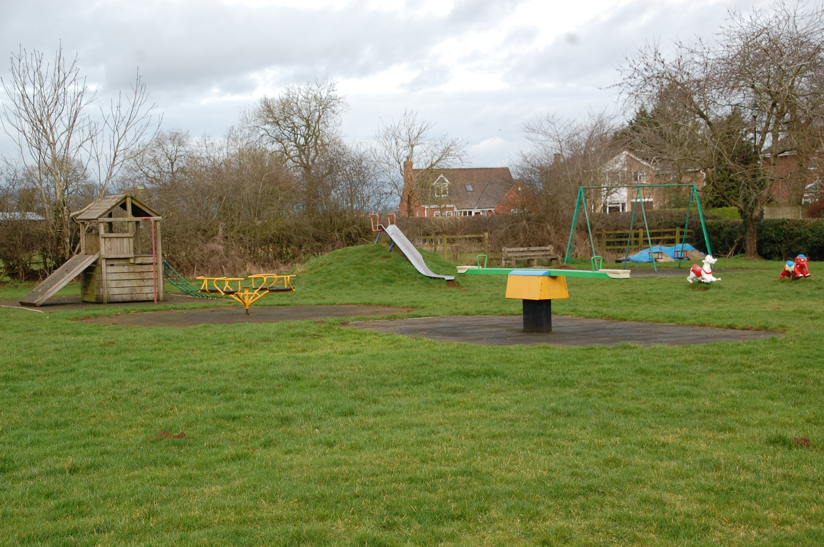

7.13 Most days children can be seen playing/enjoying the playing field and therefore it is considered to be an important resource. In addition, it is often used for community events. The field also provides the valuable space required to maintain and enhance opportunities for people to participate in outside informal activities, which in turn contributes to maintaining an active and healthy community which secures far wider reaching benefits.

7.14 The land was purchased by the Parish Council from the Official Receiver of a liquidated developer. The Land is subject to a covenant in favour of the Receiver and his Creditors which prevents the erection of any buildings and restricts the use only as a Village Playing Field.

7.15 Staverton allotments serve the community and are located on Daventry Road. They are well used and there is a waiting list. In addition they are considered to be an important historic asset for the community, and an important facility that promotes self-sufficiency and a healthy lifestyle. The Parish Council also has a legal duty to provide this facility.

7.16 Staverton is fortunate in that it has a well-used and ‘loved’ village hall that is considered to be at the heart of the community, located in the centre of the village. Although there are issues with parking 74% of the respondents to the Parish questionnaire felt the village hall would not be used more if it moved location. It is a financially self-sufficient entity, that is not a burden on the taxpayers of the village. In 1934 the land was donated to the village and the building was paid for with local fundraising events. It is currently managed by a committee of Trustees.
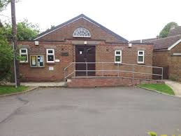

7.17 The Pocket Park was established by the Parish Council in 1993 on waste ground which was the site of a former Village Pond. After the required length of time the Parish Council secured Possessory Title to the Site. The site is too small for physical activity, but instead provides a place to sit outdoors along with providing an area where wildlife such as birds can establish a foothold.
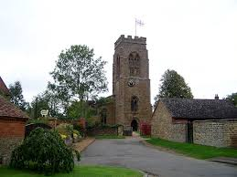

7.18 St Mary the Virgin Church has been a site of Christian worship for well over a thousand years, with the present church dating from about circa 1300. For hundreds of years before this, possibly dating back to before 800 AD, a burial ground existed on the site, as evidenced by the raised churchyard. The Church has a Parochial Church Council and a regular Sunday service is held. The Churchyard remains open and is available for burials. It attracts many visitors from UK and overseas due to its historic interest.

7.19 Staverton CE Primary School is a voluntary controlled school which caters for boys and girls from 4-11 years of age. It presently has approximately 100 children on the roll (November 2016). In August 2014 the school became an Academy with the Peterborough Diocese Education Trust. The school itself serves the communities of Staverton, Hellidon and Catesby. The children from these villages attend the school along with a number of pupils from outside these areas .

7.20 The Parish Questionnaire identified a desire amongst the community to retain The Countryman, which is the only pub in Staverton, and Skylarks Café & Farm shop. Both facilities are well used by the community and are two cornerstones of village life. In light of the current climate of villages losing their shops and pubs, which are disappearing at an alarming rate from the rural landscape this was a very positive response.

7.21 Staverton Village has for many years had a red K6 Telephone Box bearing the crest of Queen Elizabeth II, which is sited in Manor Road. The Telephone box whilst rarely used is viewed as not only an essential emergency communication facility, but also as an iconic feature of our traditional village. In response to a consultation undertaken by Daventry District Council regarding the intended removal of this telephone box by BT, representations were submitted from both Parishioners and the Parish council in support of maintaining this facility. Daventry District Council has subsequently granted it Grade 2 status as a building of historic importance, and it will therefore remain in place.

Policy

SC1.1 The change of use or demolition of any of the community facilities listed within the plan in will be supported if it were for the benefit of the community and unless one of the following can be demonstrated:

a The proposal includes alternate provision, on a site within the locality, of equivalent or enhanced facilities. Such sites should be accessible by public transport, walking, cycling and have adequate car parking.

b Satisfactory independent evidence is produced that demonstrates over a period of at least twelve months that there is no longer an economic and social justification/demand for the facility.

c That the proposal would be of benefit to the local community and would outweigh the loss of the existing facility

The existing community facilities in the village include:

Playing Field Daventry Road Allotments Village Hall
St Mary The Virgin Church Staverton C of E Primary School Countryman Public House

SC 2 Housing (inclusive of affordable housing and local connection) policy

7.22 Policy Background & Summary
Engagement throughout the preparation of the plan indicated a strong desire by the local community to maintain Staverton as a rural village, preserving its character, environment and heritage. Similarly, the vast majority agreed that there is a need for new housing and that any new housing should enhance and compliment the form and character of the village.

7.23 Staverton Parish had a population of 468 in the 2001 census reducing slightly to 458 in the 2011 Census.

7.24 The West Northamptonshire Joint Core Strategy does not set a housing requirement for Staverton Village, and it will be for Daventry District Council to do so as part of its Settlement and Countryside Local Plan. The scale of housing required within the West Northants Joint Core Strategy is (Table 3):-

Table 3 - Housing required within West Northants Joint Core Strategy
Overall Requirement for Daventry District | 12,370
Daventry Town | 4,260
Daventry Rural Areas | 2,360
Northampton Related Development Area | 5,705

7.25 Currently (November 2017) the West Northants Joint Core Strategy Policy has achieved the rural requirements to 2029 of 2360 has been met.

7.26 The Housing Need Analysis generated from the questionnaire indicated there was a mix of house types and sizes required for future housing up to 2029: 73% of those that expressed a need for future housing, indicated that flats/bungalows and 1-2 bedroom dwellings would be needed in the future.

Table 4 – Housing Need Analysis from Parish Questionnaire
No | Description | Percentage
1 | Flat | 7%
7 | Bungalows | 46%
2 | 1-2 bedroom | 13%
3 | 3 – 4 bedroom | 20%
1 | Affordable | 7%
1 | 5 bedroom | 7%
15 | TOTAL | 100%

7.27 Daventry District Council undertook a Parish Housing Needs Survey in April 2017 which identified a need for 17 properties. The SPC Housing Need Statement identifies how a housing need of 15 properties has been determined for the plan period.

7.28 Staverton is a small village with few facilities but a distinct charm, character & cohesive community. It is clear that residents of Staverton are anxious that those who want to maintain a traditional way of Village life should be able to do so. Existing residents feel that we must act as ‘guardians’ of our village to ensure that we are not forced to lose the right to a village lifestyle, by aggressive development proposals by Developers. It is strongly felt that inappropriate development would lead to a loss of Village identity, i.e. not being part of a specific cohesive community.

7.29 There is a limited amount of available land within the village confines. The plan therefore allows for some small scale development immediately adjacent to the village confines, in order to satisfy the Housing Need. The plan has chosen not to identify sites following the consultation exercise undertaken on the 18th November 2017.

7.30 Daventry District Council in November 2017 commenced a consultation exercise in relation to its Local Settlement and Countryside plan Part 2, which proposes to include an updated settlement hierarchy.

7.31 For the purpose of this SNDP, up until November 2017, we worked on the basis that our current designation i.e. restricted infill would remain. As part of the revision of the Local Settlement and Countryside plan Part 2 Staverton has been determined as a Secondary Service Village at the higher end of the hierarchy.

7.32 Consequently as the policies for the plan were produced they were cross checked against the emerging Local Settlement and Countryside plan to ensure there were no conflicting positions.

Policy

SC2.1 Planning permission will be supported for the amount of housing required to deliver the Housing Need of Staverton Parish between 2018 and 2029.

SC2.2 New housing development in Staverton Parish shall be located within or adjacent to the village confines, subject to the following criteria: -

a Be of an appropriate density in relation to the immediate surroundings
b Ensures appropriate and safe access can be achieved
c Is of a high quality design and is in keeping with the immediate surroundings, environment and rural landscape
d Demonstrates a contribution to the delivery of an appropriate mix of dwelling types and sizes including affordable housing, to meet the needs of all sectors of the community.
e Ensures appropriate parking is provided on site
f It is in keeping with the rural character of Staverton village

New housing development outside the village confines will only be acceptable where it has been demonstrated that it is required to meet an identified local need.

Map 6 - Village Confines
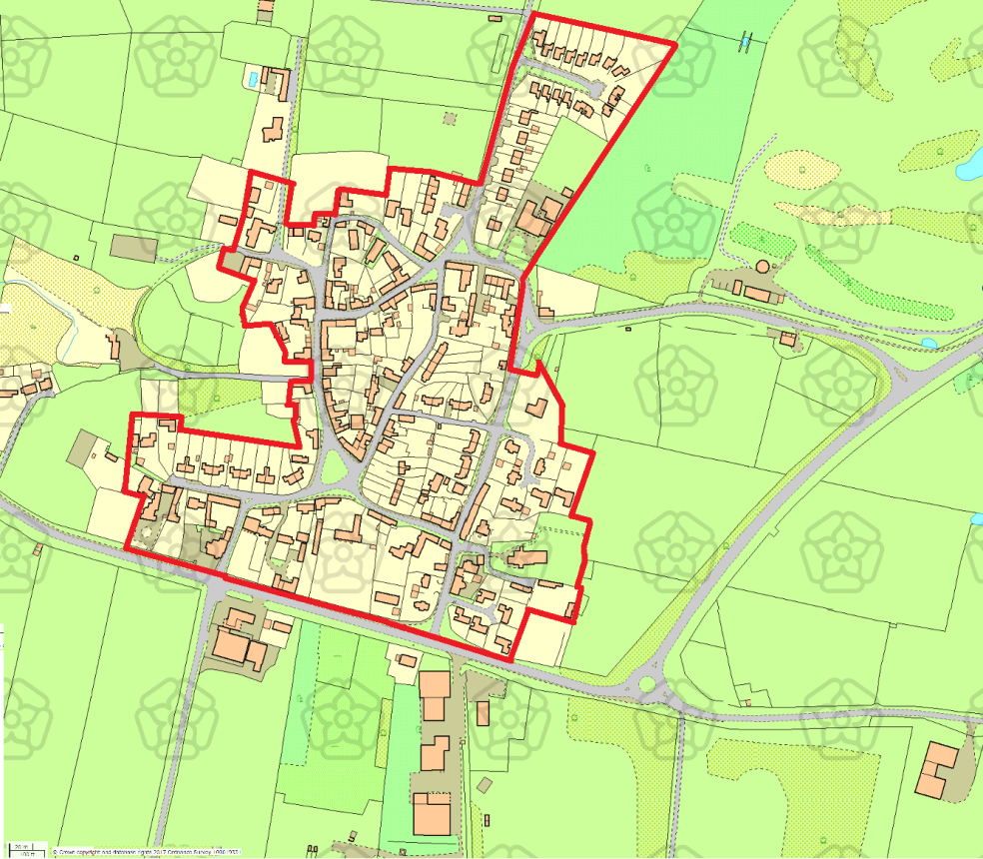

SC 3 Access policy (inclusive of footpaths, cycle ways, bridal ways & connectivity)
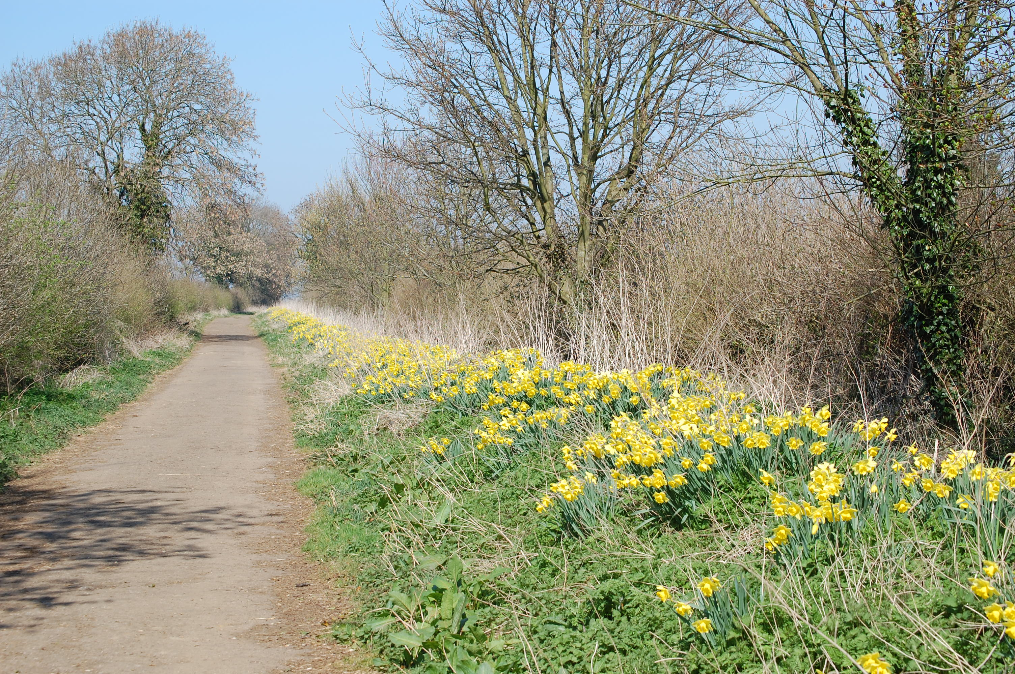
7.33 Policy Background & Summary
The SNDP seeks to support the retention and the creation of transport systems in accord with the residential character of the Parish. These includes any measures to improve car parking, and that maintain adequate access for public transport and emergency vehicles.

7.34 The West Northants Joint Core Strategy highlights the importance of improving accessibility in rural areas. The location and nature of the Parish results in the primary form of transport is private cars, vans and motorcycles. Only a small proportion of the community utilise the bus service that goes through the village.
Braunston Lane Bridle Way

7.35 There is a low-floor bus service between Daventry-Staverton-Southam-Leamington-Southam-Banbury, operated by Stagecoach in Warwickshire from Monday to Saturday. There is also a bus service from Daventry which connects to Northampton & Rugby as well as the County connect service. The Parish Council will work with and encourage providers of public transport to provide as full a service as is needed, to support the future development in the village.

7.36 There are regular train services between Northampton/Long Buckby/Rugby and London/Euston/Milton Keynes & Birmingham. Main line connections can be made at Northampton/Long Buckby/Rugby & Banbury.

7.37 Some of the highest traffic growth in recent years has been on routes in rural areas, with increased congestion having a detrimental impact on villages. The volume and speed of the traffic passing through the village on both the old and new Daventry Road (A425) is considered to be an issue, with traffic speeds in excess of the 30 miles per hour limit often being raised as a concern.

7.38 Parking is also an issue in some parts of the village, especially near the school at the beginning and end of the school day. Therefore appropriate solutions which remedy this issue will be supported.

7.39 Traditional traffic management, such as signing and bollards may detract from the overall character of the village, therefore different approaches for limiting traffic are required. Actions that would make the village a more attractive and accessible place for pedestrians and cyclists are favoured, with residents keen to see measures to promote safe roads and footways and discourage through traffic.

Policy

SC3.1 Proposals for improvements in road safety (especially around the vicinity of the local Primary School), traffic management and the provision of improvements to public transport will be supported where they are in keeping with the character of the village.

SC3.2 Developer contributions and CIL payments will be sought towards the following within the Parish where it is in keeping with the character of the village:

a Traffic calming measures
b Pedestrian priority schemes
c Reduction in speed on both the old and new Daventry Road (A425)
d Retain and increase public and community transport to and from the village

SC3.3 To support a School Travel Plan in order to reduce any traffic congestion from any future development in the village.

SC3.4 Proposals for improved linkages and accessibility of Staverton to the surrounding areas will be supported.

PE 1 Protecting and enhancing the landscape and character policy

7.40 Policy Background & Summary
Staverton lies in the South-West of Northamptonshire England, it is approximately 2 miles West of Daventry, 8 miles East of Southam, and 15 miles East of Leamington Spa. The Parish straddles the A425 road from Daventry to Leamington.

7.41 The ground rises over 100metres (328`) across Staverton Parish, from around 120M (400`) above sea level where the A425 continues North West into Warwickshire, to some 222 Metres ( 728`) at the summit of Big Hill to the South.

7.42 Arbury Hill, part of which lies within Staverton Parish, the highest point in Northamptonshire at 225M (738`) is around 1.5 miles to the South West of the village. On its summit there is evidence of an Iron Age hill fort of an unusual square shape. These hills define a significant national watershed where oddly streams that leave the Staverton side of Big Hill and Staverton Clump heading east toward Daventry, join the Leam then into the Warwickshire Avon, flow on into the Severn, then ultimately into the Bristol Channel on the west coast of England, and streams leaving Big Hill to the West soon contribute to the Nene, which also rises within the parish, flowing right through Northamptonshire, ultimately into The Wash on the opposite, eastern side of the country.

7.43 Also, around 3 miles to the South West, within these hills near the village of Hellidon – itself part of the Staverton School catchment area, the river Cherwell has its source The Cherwell seeks yet a different route to the coast – South then via the River Thames, onward to the North Sea in the South East.

7.44 The 88 mile Jurassic Way, which guides the long walk from Banbury to Stamford, follows a route through Staverton. The much shorter Three Rivers Ramble Circular Walk, passing near the source of the rivers Nene, Leam and Cherwell, dips in and out of the Parish and the Nene way if started from the river`s source, provides Staverton with yet another opportunity for walkers to find adventure.

7.45 The Parish is predominantly rural in character as defined in the Environmental Character and Green Infrastructure Suite 2007

7.46 Staverton owes much to its farming heritage. The landscape bears the imprint of changes over many centuries and today`s farmers play a crucial role in its preservation, even if they now form only a small part of the working population. Much land is under the plough for cereals, animal feed and more recently for green energy supply.

7.47 Grassland, grazed mainly by sheep and a few cattle, is still a distinctive landscape feature. Horses are kept for racing or recreation, but the pig is conspicuous by its absence, no longer kept by a family to be slaughtered and preserved for winter meat.

7.48 There is a wide variety of both flora and fauna in the parish. Huge ash, oak and beech, Horse chestnut, sweet chestnut, Lime and a variety of conifers. Silver birch and rowan are few in number with yew largely confined to the churchyard. Elm is struggling on in the hedgerow a mere remnant of its dominant place both as a feature and the resource of centuries past

7.49 Wild flowers abound, with the primrose and cowslip a joy to find unexpected when walking. In the woods early in the year the delicate wood anemone and otherworldly flush of bluebells can saturate the senses. The miniature scarlet pimpernel, buttercups daisies celandines, clover, wragged robin, red and white campion, marsh marigolds, the list goes on. The hedgerows deliver sweet spring leaves followed in turn by blossom and fruit. Gathered and used to make wine, jams and preserves the local countryside offers much.

7.50 Many Pipistrelle bats are present at dusk, and feed around the mature sycamore trees. Foxes are both friend and foe. Keeping rodents in check but choosing chicken when available. Being top of the food chain has it`s pressures. The badger too is abundant locally again eating the best of what is available, not always to the delight of others. Rabbits, weasles, stoats, rats, mice, voles, moles are all found locally, along with grass snakes and the occasional adder. The wealth of birds seen in and around the Parish at various times of the year include Swifts and Swallows, Song thrushes, Fieldfare, Goldfinches amongst many visitors, with long tailed, blue, great and coal tits busy all year round. Both Greater spotted and Green woodpeckers can be seen and heard, with Kestrel, Buzzard and the occasional Red Kite to be seen checking the larder. Rooks, Crows, Wood Pigeon, Blackbirds, Sparrows, Wrens all contribute to the day to day experience of living in the Parish with few demands made in return.

7.51 The whole of the Parish falls within Daventry District Council’s Special Landscape Area designation. This is particularly relevant for any development proposals outside of the village confines. 67% of the respondents from the Parish Questionnaire felt conserving the Special Landscape Area and protecting the local wildlife and habitats were the two top priorities for the village.

7.52 The Parish has a Grade I listed church, 25 Grade II listed buildings, one pocket park, one registered Village Green and a playing field.

7.53 The residents, Parish Council and SNDP committee consider it highly important to protect the setting of the village and surrounding rural character of the landscape. The Parish Questionnaire specifically identified that there was a need to maintain the rural character of the village. To preserve this rural character there is a need to ensure a separation of the various settlements between Staverton and neighbouring urban developments.

Policy

Planning permission for development in the Special Landscape Area as defined by the Daventry Local Plan, will be supported provided that:-

PE1.1 It meets the Housing Need of Staverton Parish in accordance with Daventry planning policies.

PE1.2 It does not adversely affect the character of the local landscape.

Development proposals must demonstrate account has been taken of the following landscape and character design principles:

a Preserve or enhance the character of the Village. Schemes will be expected to conserve and protect the integrity and fabric of historic buildings and their settings.

b Preserve or enhance local habitats and wildlife corridors. Landscaping schemes would be required to incorporate planting schemes which use traditional and locally appropriate species to support and enhance biodiversity. Species should be appropriate to the location and setting in terms of type, height, density and should consider the need for ongoing maintenance.

c Conserve important local landscape features such as existing hedgerows, or establish new native hedges to support and protect wildlife.

d Protect mature established trees and incorporate them into landscaping schemes wherever possible.

e Protect locally significant views. Any developments would be required to take into consideration adverse impacts on these views through landscape appraisals and impact studies. Important views are shown on page 45.

f Conserve traditional farm buildings through continued and appropriate new uses. Repairs and alterations should use local materials and techniques wherever possible.

g Include noise attenuation measures and visual screening of transport corridors such as main roads and rail routes where there is an adverse impact.

h Ensure that any lighting is purposeful and does not generate intrusive and unnecessary spillage, which would cause light pollution.

PE 2 Open/Green Spaces policy

7.54 Policy Background & Summary
Staverton Parish has a network of footpaths and open spaces, linking facilities around the village, open countryside and long distance footpaths. The top two activities undertaken by residents as identified in the Parish questionnaire were Walking/Rambling (42%) and Dog Walking (36%).

7.55 In terms of protecting the existing open spaces in the village 74% of residents felt the retention of Open Spaces was very important.

7.56 The NPFF advises at paragraph 76 that “local communities through local and neighbourhood plans should be able to identify for special protection green areas of particular importance to them. By designating land as Local Green Space communities will be able to rule out new development other than in special circumstances.

7.57 Paragraph 77 of the National Planning Policy Framework advises that ‘the Local Green Space designation will not be appropriate for most green areas or open spaces. However, the designation should only be used:

- Where the green space is in reasonably close proximity to the community it serves
- Where the green area is demonstrably special to a particular local significance eg. Because of its beauty, historic, recreational value tranquillity or richness of its wildlife:
- Where the Green area concerned is local in character and is not an extensive tract of land

7.58 The table below sets out how each of the proposed protected local green spaces meet these criteria. In addition the Local Green Space nomination form has been completed and approved by Daventry District Council (Table 5).

Table 5 – Protected Green Spaces
Ref | Name | Location | Significance
1 | Playing Field | Braunston Lane | The green space is in reasonably close proximity to the community it serves  The green area is demonstrably special to a particular local significance eg.  Because of its beauty, historic, recreational value tranquillity or richness of its wildlife:
2 | Village Green | The Green | The green space is in reasonably close proximity to the community it serves  The green area is demonstrably special to a particular local significance eg.  Because of its beauty, historic, recreational value tranquillity or richness of its wildlife:  The Green area concerned is local in character and is not an extensive tract of land
3 | Pocket Park | Junction Glebe Lane/  Daventry Road | The green space is in reasonably close proximity to the community it serves  The green area is demonstrably special to a particular local significance eg.  Because of its beauty, historic, recreational value tranquillity or richness of its wildlife:

Policy
PE2.1 The local Green spaces identified on Map 11 page are designated in accordance with paragraphs 76 & 77 of the National Planning Policy Framework:

Playing Field
The Village Green
The Pocket Park

PE2.2 New development which impacts adversely on the function, openness and permanence of these sites will not be permitted unless in very special circumstances.

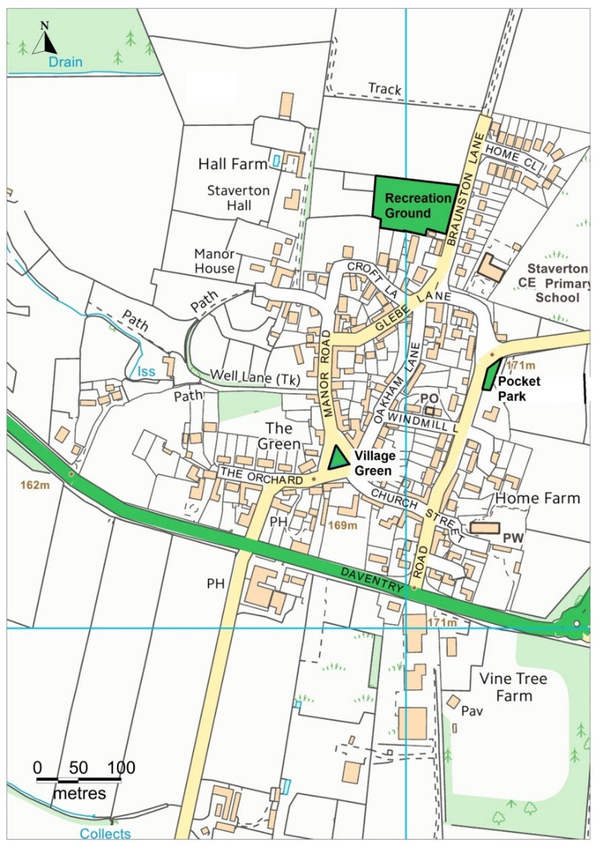
Map 11 –
Green Spaces Map

Playing Field

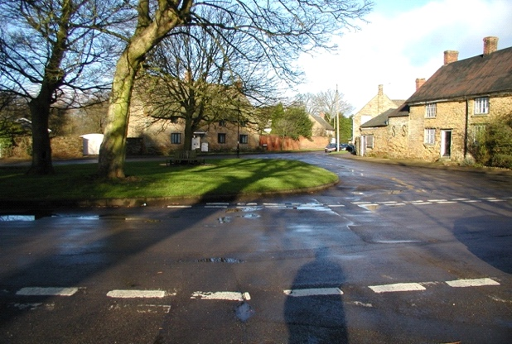
The Green

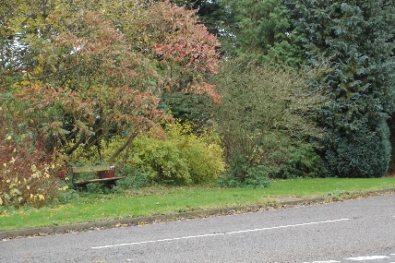

Pocket Park

MC 1 DEVELOPMENT POLICY

7.59 Policy Background & Summary
This is a general policy which relates to all types of existing and new development that requires planning permission.

7.60 All new development will be expected to enhance the positive attributes of the village and local design features. Development will not be permitted where it has a detrimental impact on the character of the village/area in which it is located.
Policy
MC1.1 New developments, alterations, or change of use to existing buildings within the village will be supported when they meet the following criteria, and other policies set down in this plan.

In assessing the suitability of sites for development proposals will be supported provided that:

a The new housing development is located where it is contiguous with the built form
b Be small scale, proportionate to the size of the settlement
c Consideration will be given to the scale and detail of the proposal in relation to the immediately adjoining area, including streets and open spaces, and the attractive mixed character of the village as a whole
d Be of appropriate density within the context of the immediate surroundings
e Ensures appropriate and safe access can be achieved
f There being no loss of a village amenity
g That the site will protect residential amenity by reason of noise, nuisance or infrastructure.
h That the rural character of the village will be maintained
i That the site is socially and environmentally sustainable
j There is an appropriate mix of tenure, type and size of houses
k To include appropriate on-site parking commensurate with the size of property

MC1.2 Development outside the village confines will only be acceptable in:

a Exceptional circumstances or where it is demonstrated that it is required to meet an identified local need.
b If it does not result in the loss of existing services and facilities important to the sustainability of the settlement
c Protecting the form, character and setting of the village and areas of historic or environmental importance including those identified in conservation area appraisals
d Protecting the integrity of garden or other open land that makes an important contribution to the form, character and setting of the settlement;
e Being accessible by walking and cycling to the majority of services and facilities within the settlement;
f Protecting the amenity of existing residents.

7.61 The Daventry District Local Plan 1997 identifies Staverton as a Restricted Infill Village in Policy HS22. Planning permission will normally be granted for residential development in the restricted infill villages provided that:

- It is of a small scale
- It is within the confines of the village
- The proposal is in keeping with the character and quality of the village environment

7.62 The draft (November 2017) Daventry Settlements and Countryside Local Plan Part 2 consultation document defines Staverton as a Secondary Service Village - These settlements have a more limited range of services, but still provide scope to meet some local needs for housing, employment and service provision;

7.63 As part of the plan making process a village confines map has been agreed with Daventry District Council ????? page ? to help provide clarity for decision making and reflect the role of Staverton being at the higher end of the hierarchy.

the character of the village/area in which it is located.
Policy
MC1.3 Within the scope of the higher hierarchy of the village, there may be scope for development outside the confines but only in the following exceptional circumstances;

a Where the housing land supply is less than five years (three years where a neighbourhood development plan is in place that allocates sites for housing); or
b Where the housing provided would clearly meet an identified local need such as that identified through an up-to-date Housing Needs Survey carried out by Daventry District Council;
c Where a scheme is required to support an essential local service that has been demonstrated to be under threat, especially a primary school or primary health service.

7.64 The West Northants Joint Core Strategy proposes that housing growth figures are distributed across a hierarchy of settlements. The Spatial Strategy for Rural areas stipulates that development within rural areas will be guided by this hierarchy. Although this hierarchy has yet to be determined by Daventry District Council in the emerging Settlements and Countryside Local Plan, there is an assumption for the purpose of this plan that the current status of restricted infill applies.

7.65 Results from the Parish Questionnaire revealed that there was a clear view amongst respondents that development should be on a small scale, in keeping with the rural character of the village.

7.66 Photographs below show examples of recent appropriate infill development within the village:
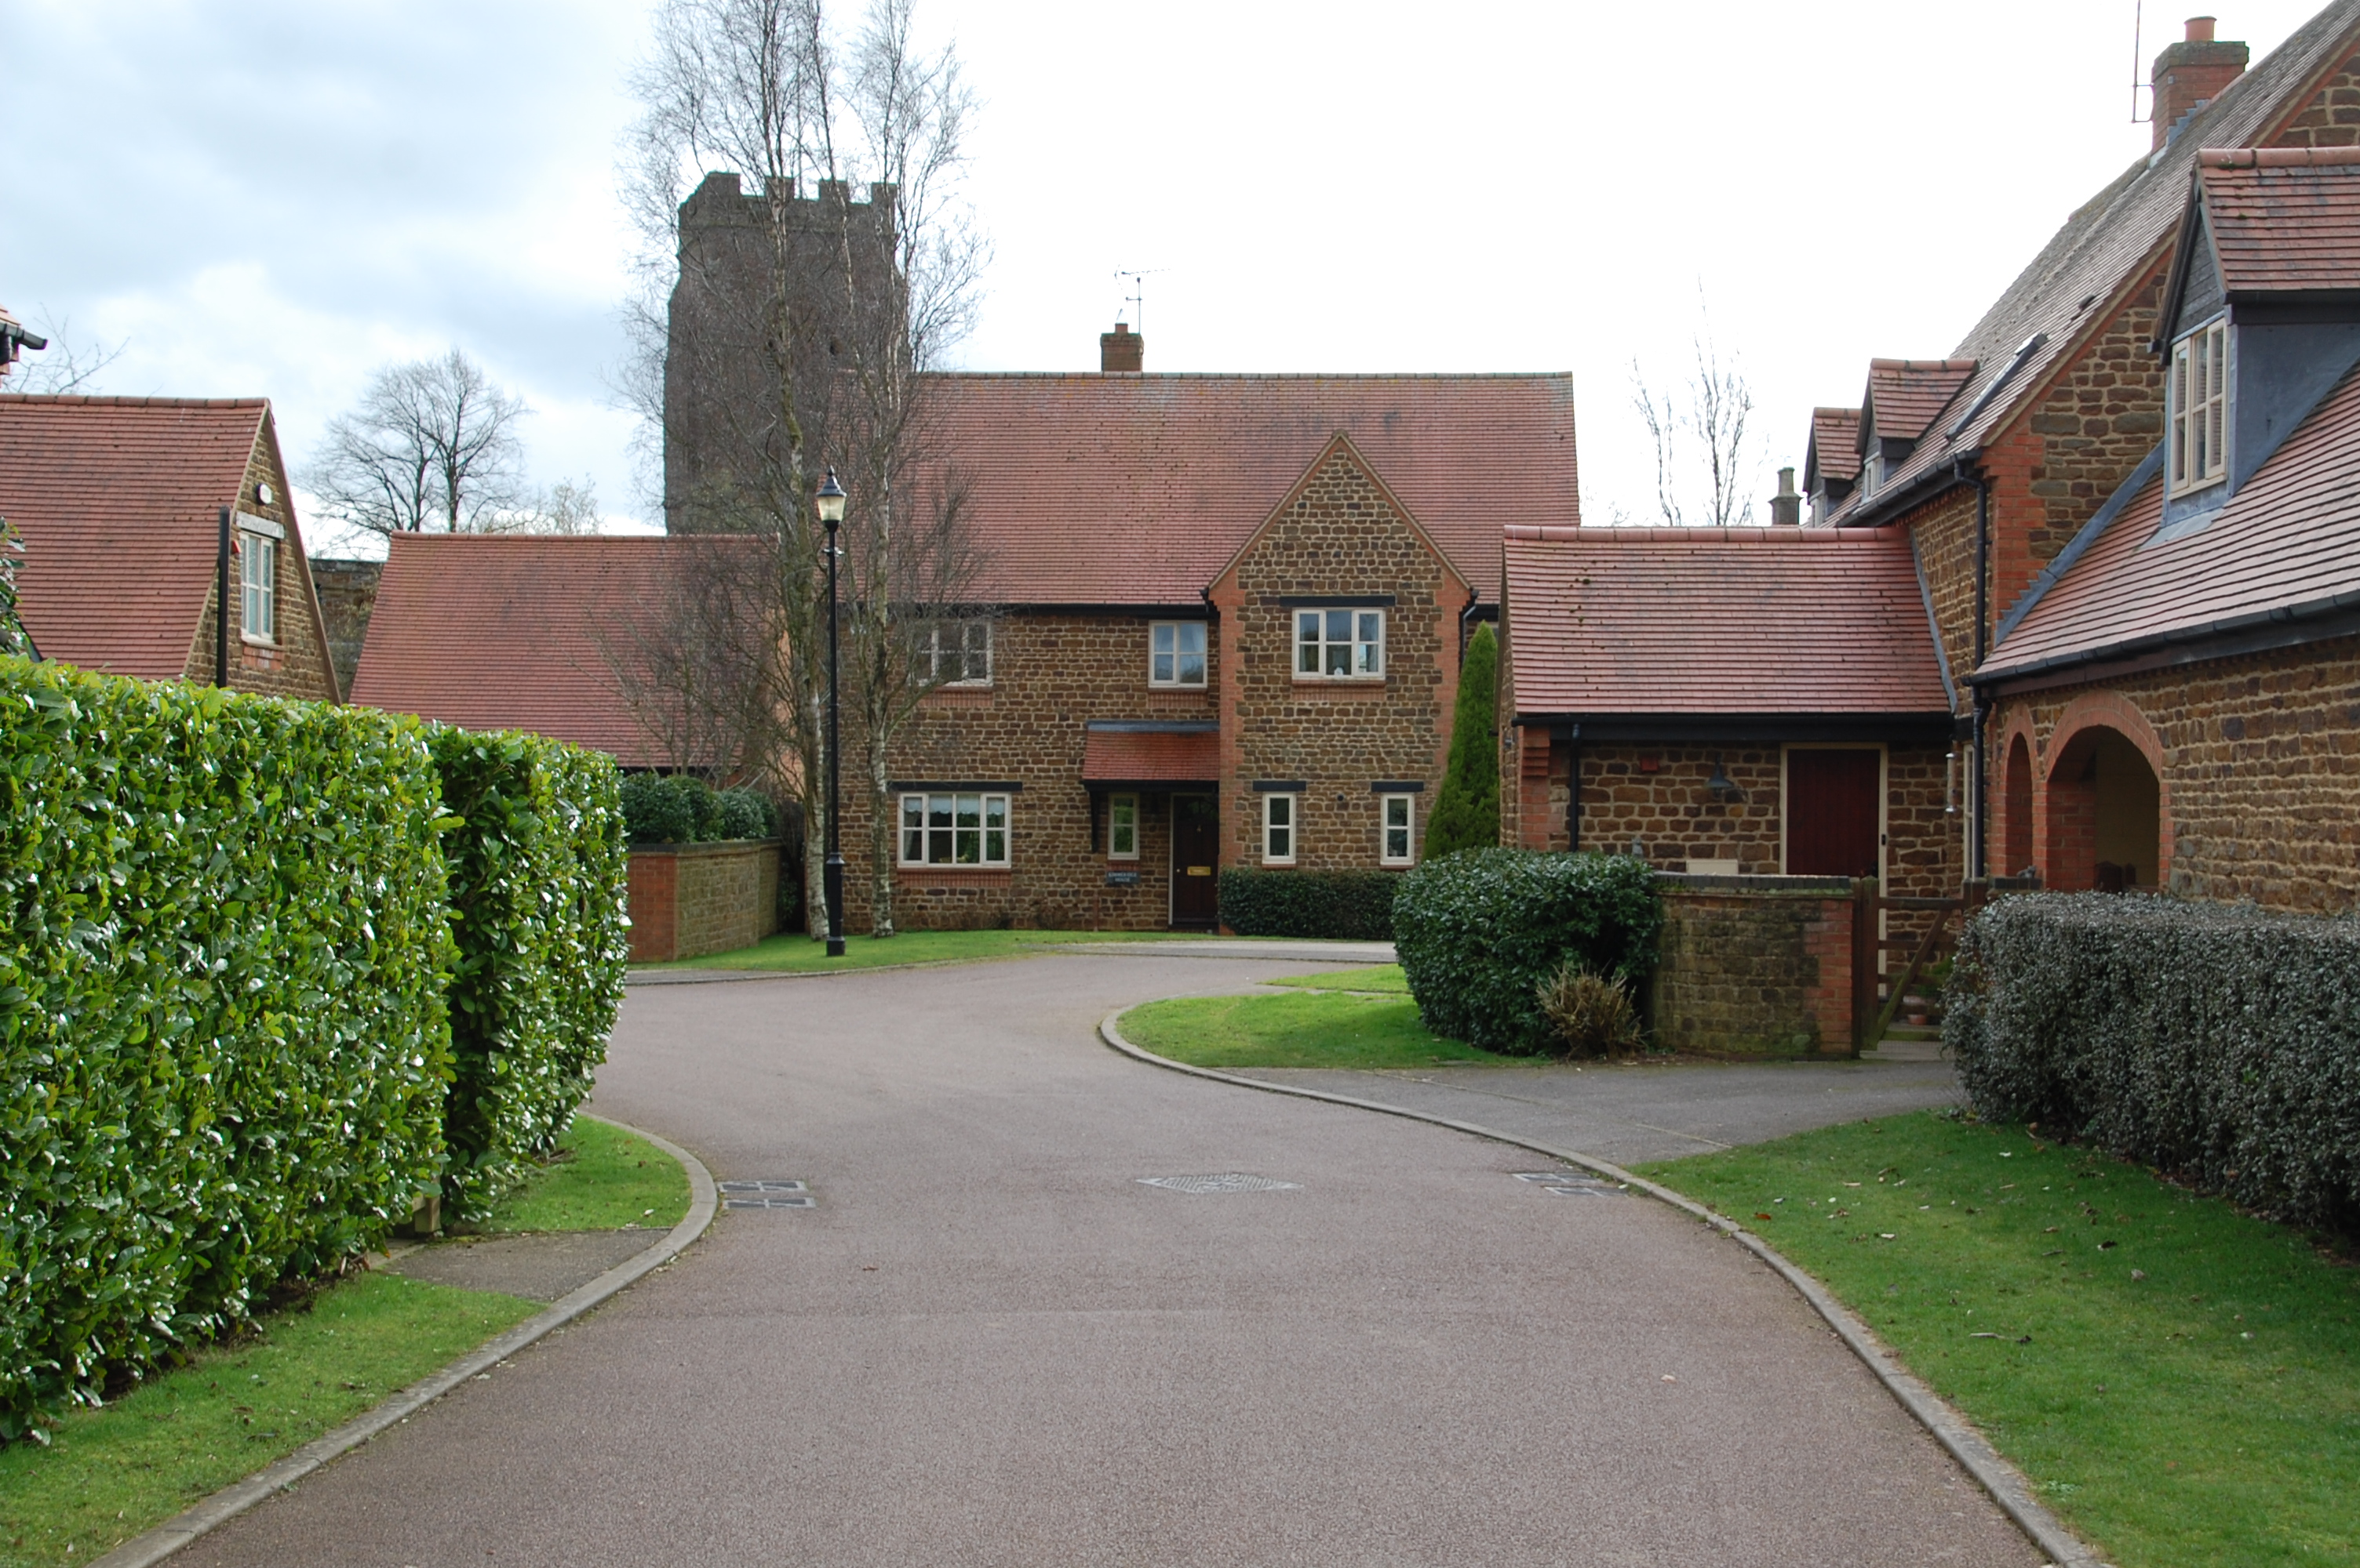
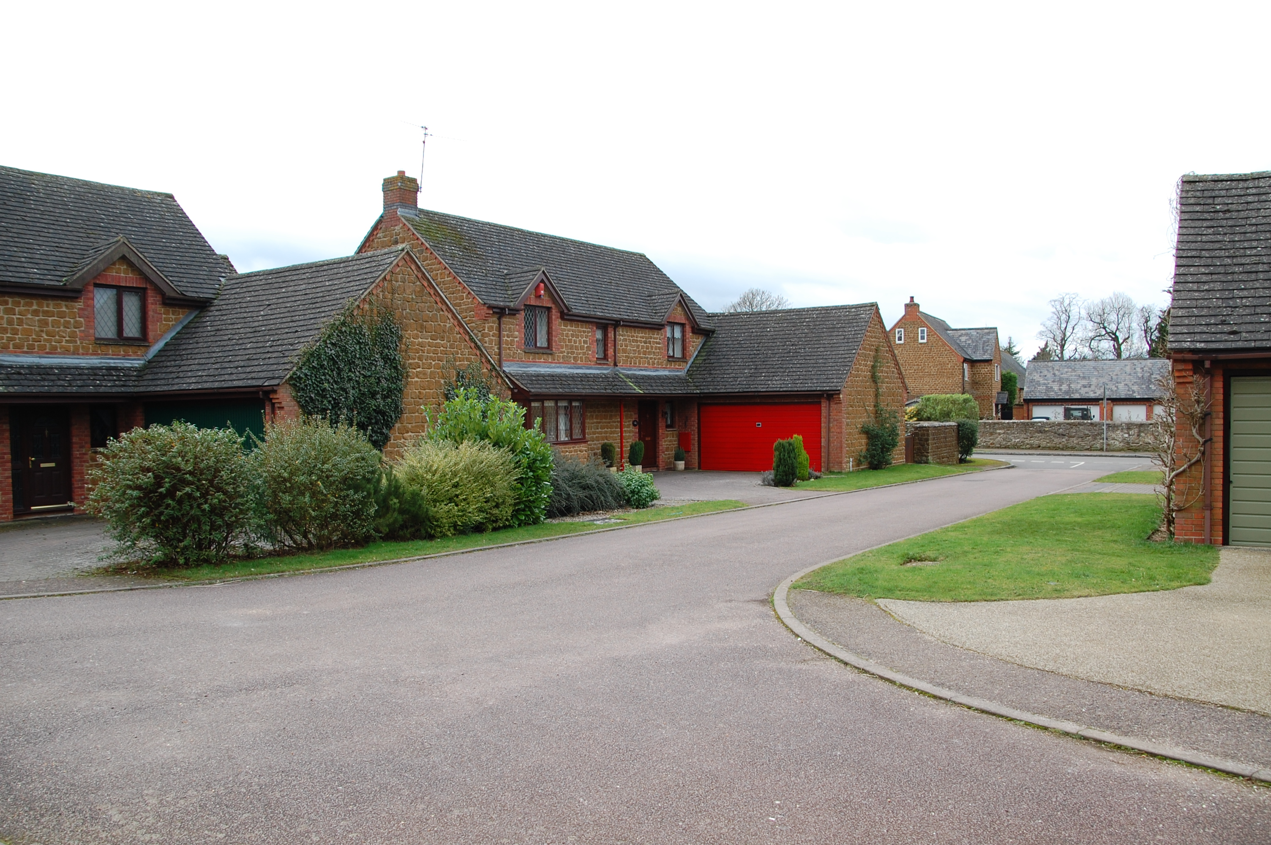

Windmill Gardens
Church Fields

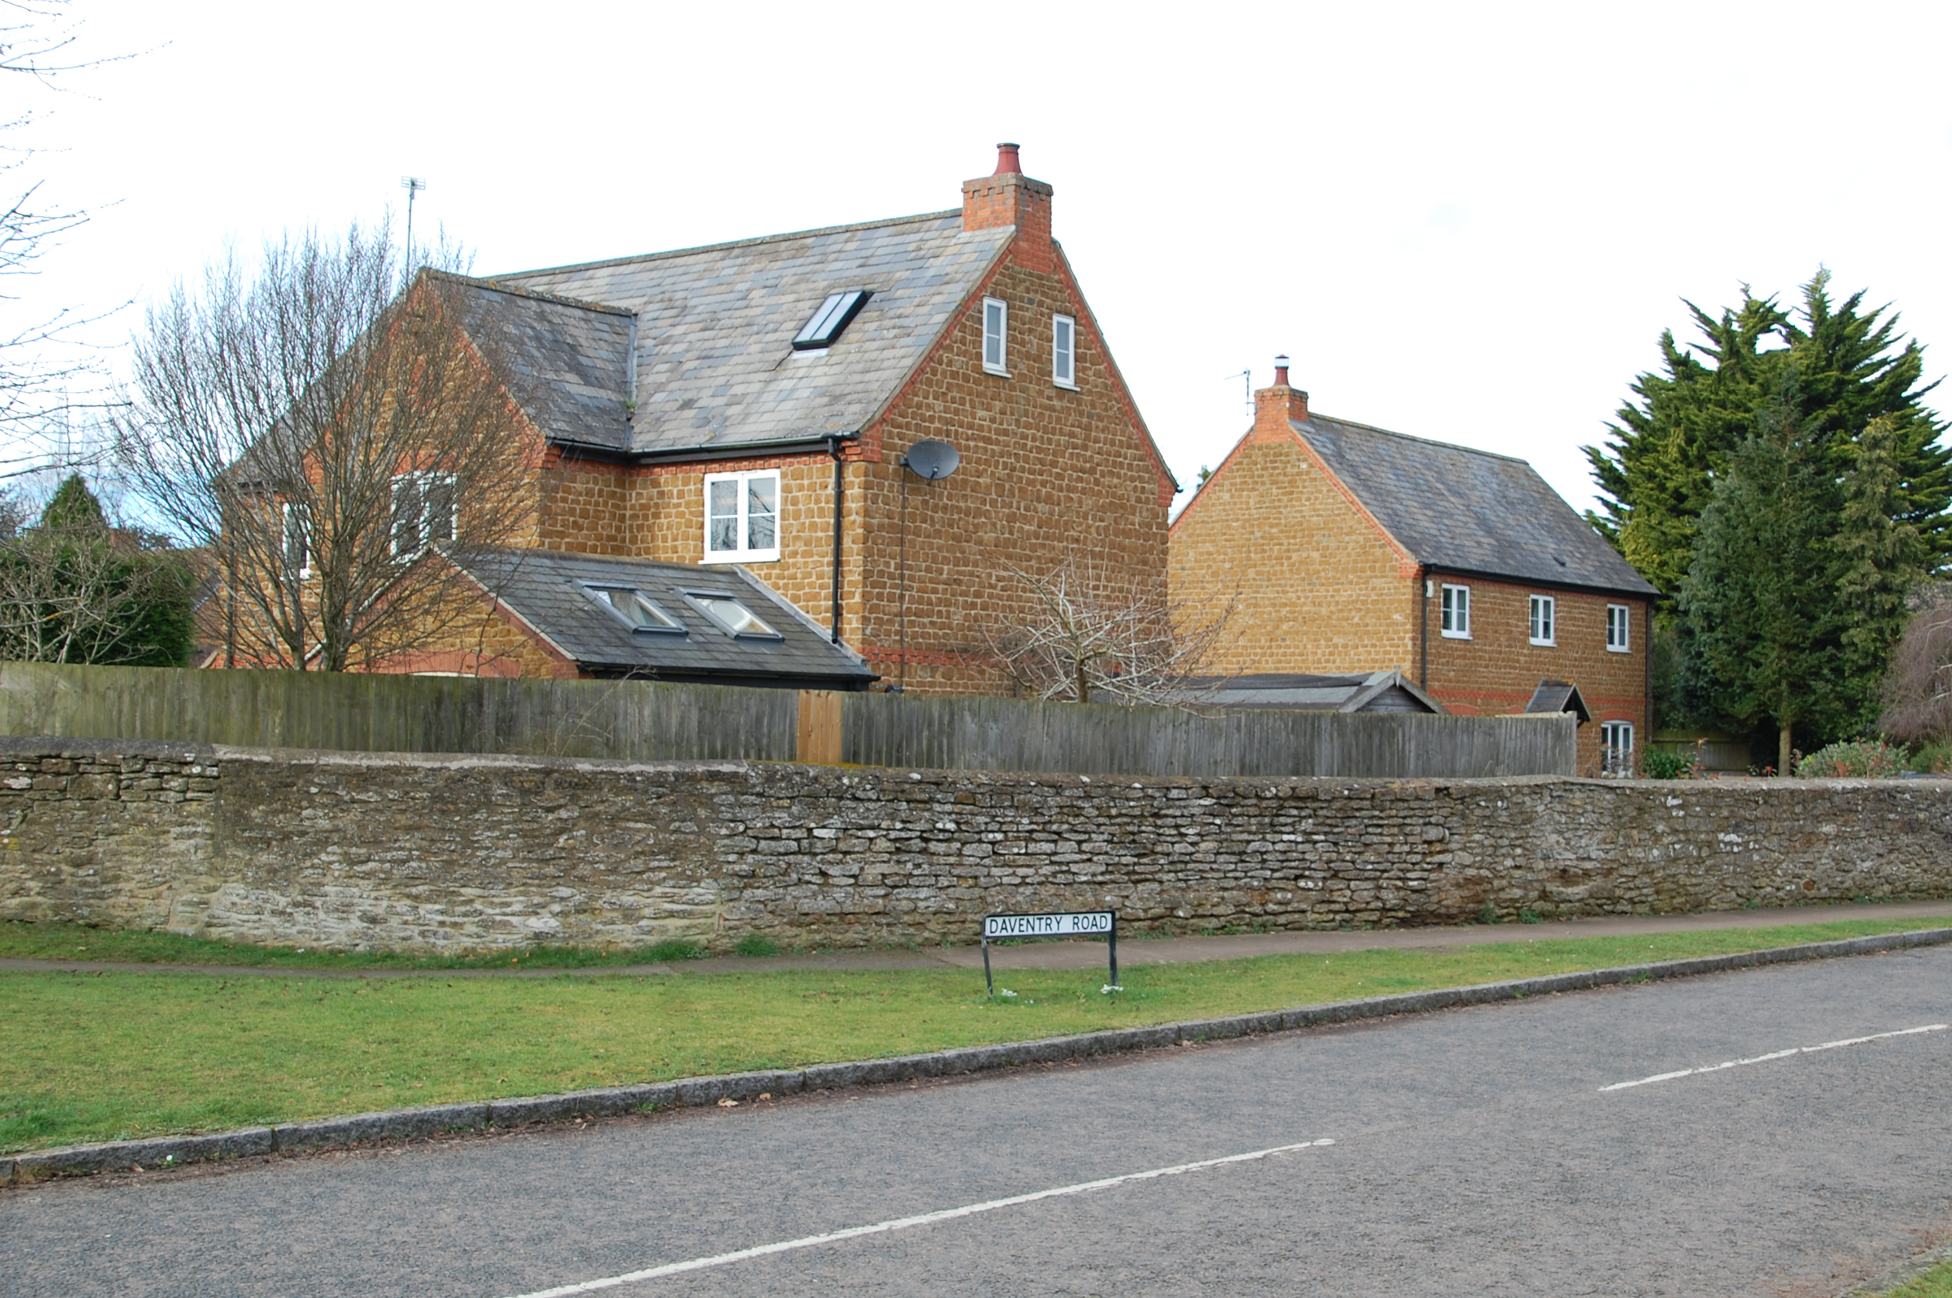
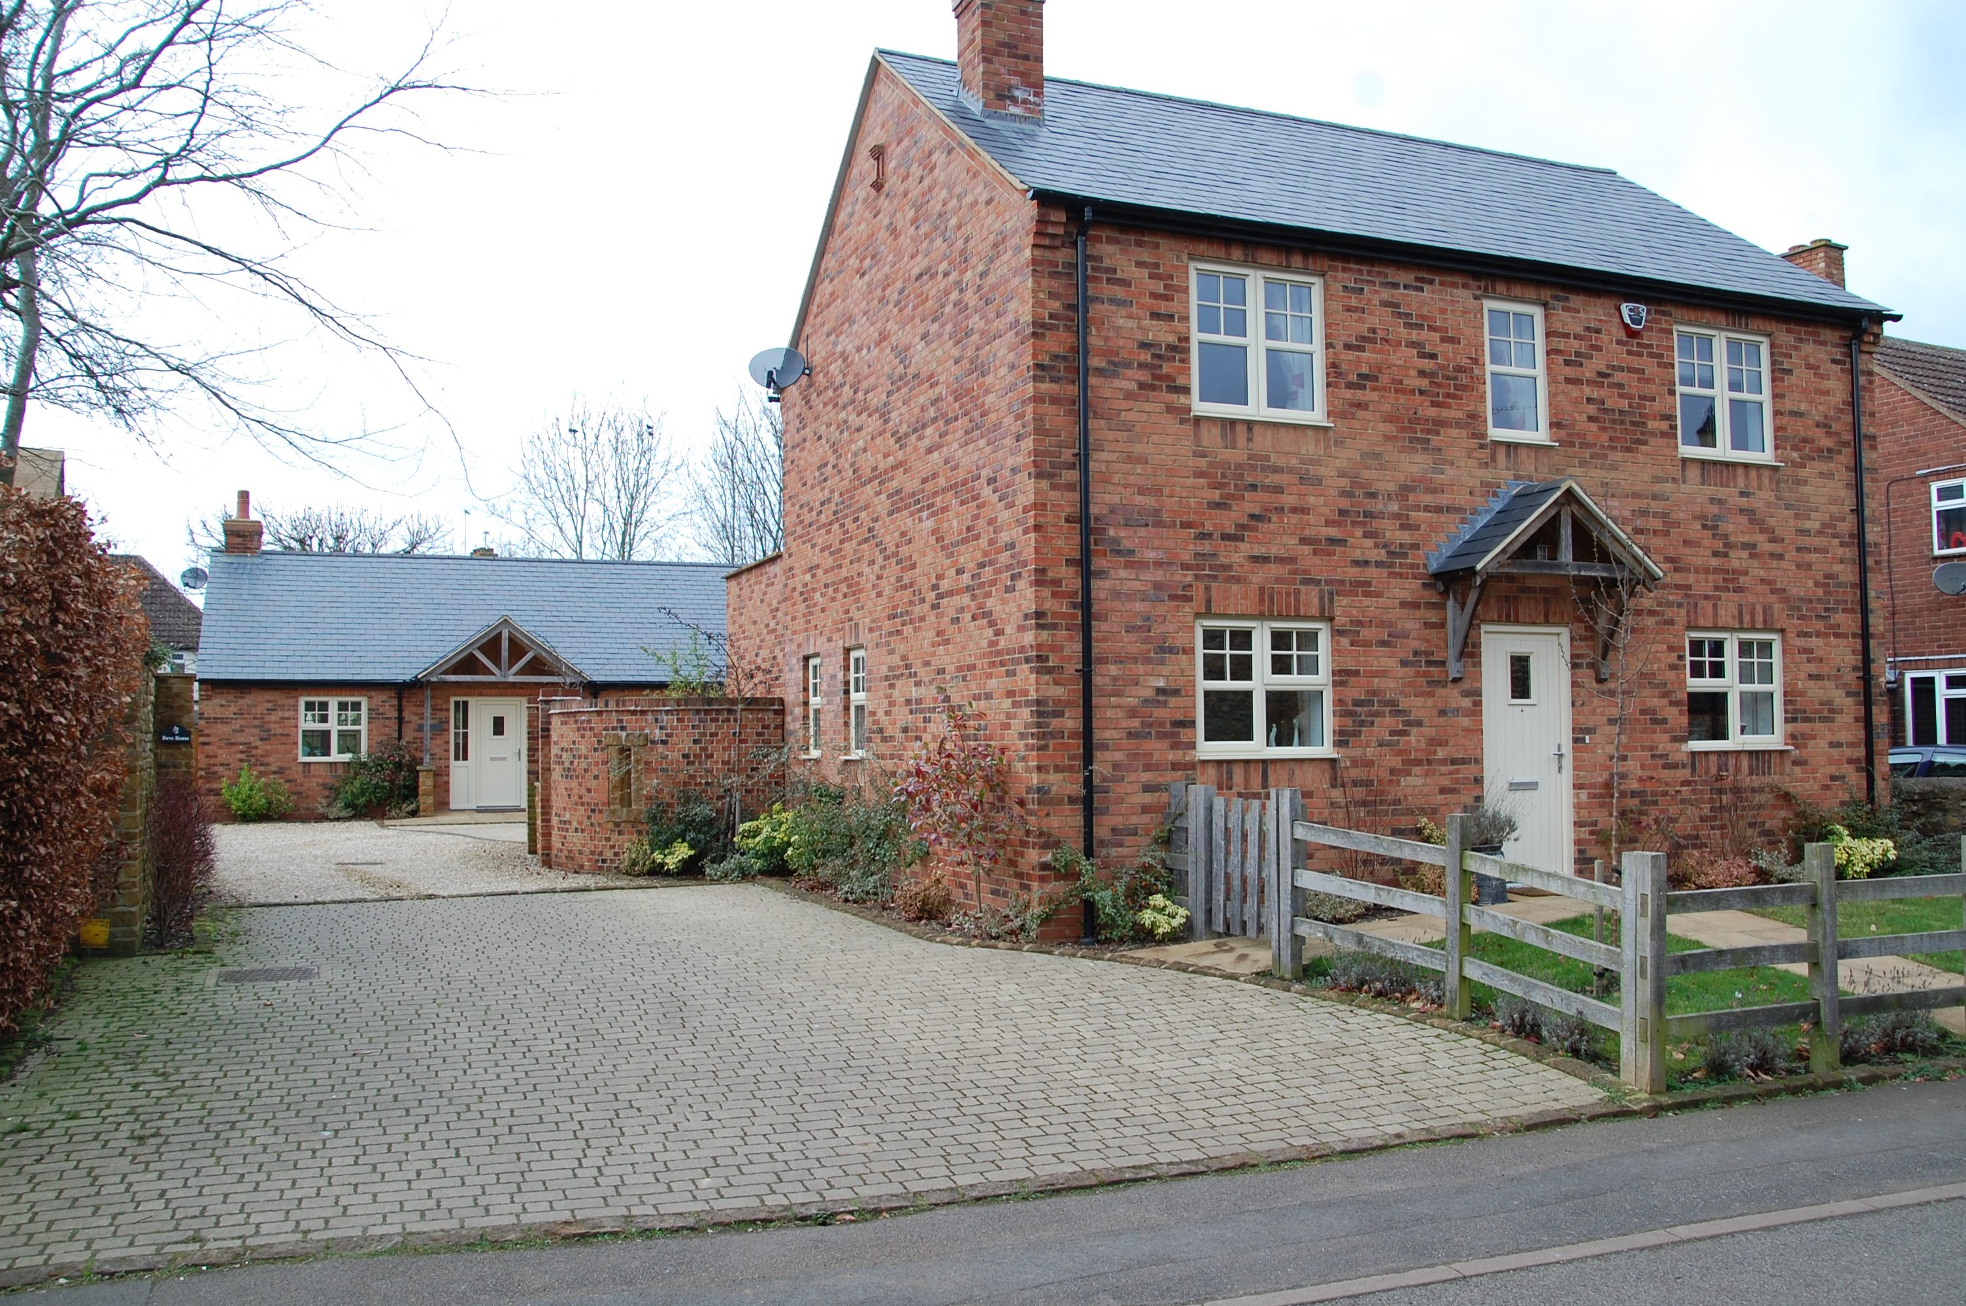

Old Gardens
Old Daventry Road Road

MC 2 Design of Development Policy

7.67 Policy Background and Summary
Staverton Parish Council considers it to be essential that the character of the village and the surrounding landscape should be retained.

MC 2 Policy – All new developments should make a positive contribution to the distinct character of the area and be of good design and quality. In seeking to protect and enhance the area, all development will be expected to take account of the following:
a Staverton Parish Council will protect and preserve the playing field and allotments, as public amenities. Staverton Parish Council considers that the retention of a barn on the playing field is necessary to ensure (a) the sustainability of the playing field as it receives rental from the barn (b) as a precedent for any future replacement of the current building.
b Staverton Parish Council considers Well Lane (believed to be one of the oldest lanes in the village) a lane of particular interest due to its visual characteristics and historic value. It should be protected from development that would adversely affect its physical appearance or would give rise to a material increase in the amount of traffic using it.
c Further development of Catesby Lane towards Hellidon would not be supported, as this would adversely change the intrinsic nature of the lane.
d Further development of Badby Lane towards Newnham would not be supported, as this would go against the policy of having any new development integrated into the village.
e Staverton is not classified as a designated business area. The current commercial B8 classification of the premises at Vine Tree Farm, has been developed from disused agricultural buildings. In keeping with the rural nature of the village, Staverton Parish Council would not support the further development or reclassification of use (EM3, EM7 and EM10)
f Development of sites considered to be of historical importance e.g the site of the original village, located to the East of the village, would not be supported.
g Street furniture, posts, bins, signs etc. should be minimised and designed and sited as unobtrusively as is consistent with their basic purpose.

h In any planning application the reduction of on-street parking should be an important factor. The loss of existing off-street parking will be resisted.

I Heavy traffic should be signed away from the village and entry and speed restrictions considered.

j Historic stone boundary walls are a particular feature within the Village which will be preserved.

k In the village centre the style of the streets, (terraced cottages fronting onto footways, two storey buildings, local stone and slate roofed structures) must be maintained.

l The general layout and style of developments should be sympathetic to that already existing in the locality

m A wide variety of building types and designs have been inherited over time and are now seen as harmonising well together in an attractive combination. The continuation of this sort of variety is desirable.

n Experience indicates that non-traditional building materials often blend in with the old, given the mellowing of time; (e.g.: thatch to slate to tile). While stone and slate should be preferred, therefore, other building materials are acceptable provided they harmonise with their immediate neighbourhood in colour and appearance and are not used in quantities which detract from earlier buildings.

o Modern designs incorporating the straight lines and sharp corners not found in older buildings can be a greater problem. Care also needs to be taken to ensure that the layouts of houses in any new streets developed fit in with the general character of the village.

p Terraced building represents a traditional and preferred method for less expensive housing.

q There should be suitable overall roof height restrictions having regard to the immediate locality.

MC 3 Infrastructure Policy

7.68 The majority of roads in Staverton (particularly the older part of the village) are narrow and unsuitable for large amounts of traffic, in particular Oakham Lane, Croft Lane, Windmill Lane, Church Street and Well Lane. Any development which would increase traffic on these roads will be resisted.

7.69 The entry to the village adjacent to the Countryman Pub is considered difficult and somewhat unsafe due to the quantity and occasional speed of traffic on the A425 in addition to being at the top of a ‘blind hill’. Therefore Staverton Parish Council opposes any development which would exacerbate the current situation.

MC 3 Policy Developer contributions and Community Infrastructure Levy will be sought towards proposals to improve the highway infrastructure. Priority will be given to the following proposals:

MC3.1 New development shall be designed to dispose of surface water either by soak away or to adjacent natural watercourses.

MC3.2 Sustainable drainage systems should be incorporated to achieve this when necessary and appropriate.

MC3.2 New development must be specifically designed, to ensure that the sewerage generated can be disposed of adequately without any detrimental effect

MC3.3 Traffic calming measures and the reduction in traffic speeds

7.70 Staverton Parish Council will seek the following improvements to road safety, traffic management and public transport:

- Highway improvement schemes to promote the safety of pedestrians and cycle users
- Traffic calming measures, pedestrian priority schemes and the reduction in traffic speeds on routes within or adjacent to the village confines
- Increasing public and community transport

7.71 The Parish Council will work with and encourage providers of public transport to provide as full a service as is needed

7.72 Seek provision for sustainable transport measures through:

- Pavements and cycle paths to enable residents of all ages and abilities to walk, cycle or utilise mobility vehicles safely from their homes to connect with existing footways, where available, in order to gain access to village services and facilities.
- Provide where possible, and where funding and developer contributions allow, new pedestrian and cycle routes or improving existing village networks to serve new development
- Contribute to establishing or enhancing pedestrian and cycle routes within the villages;

