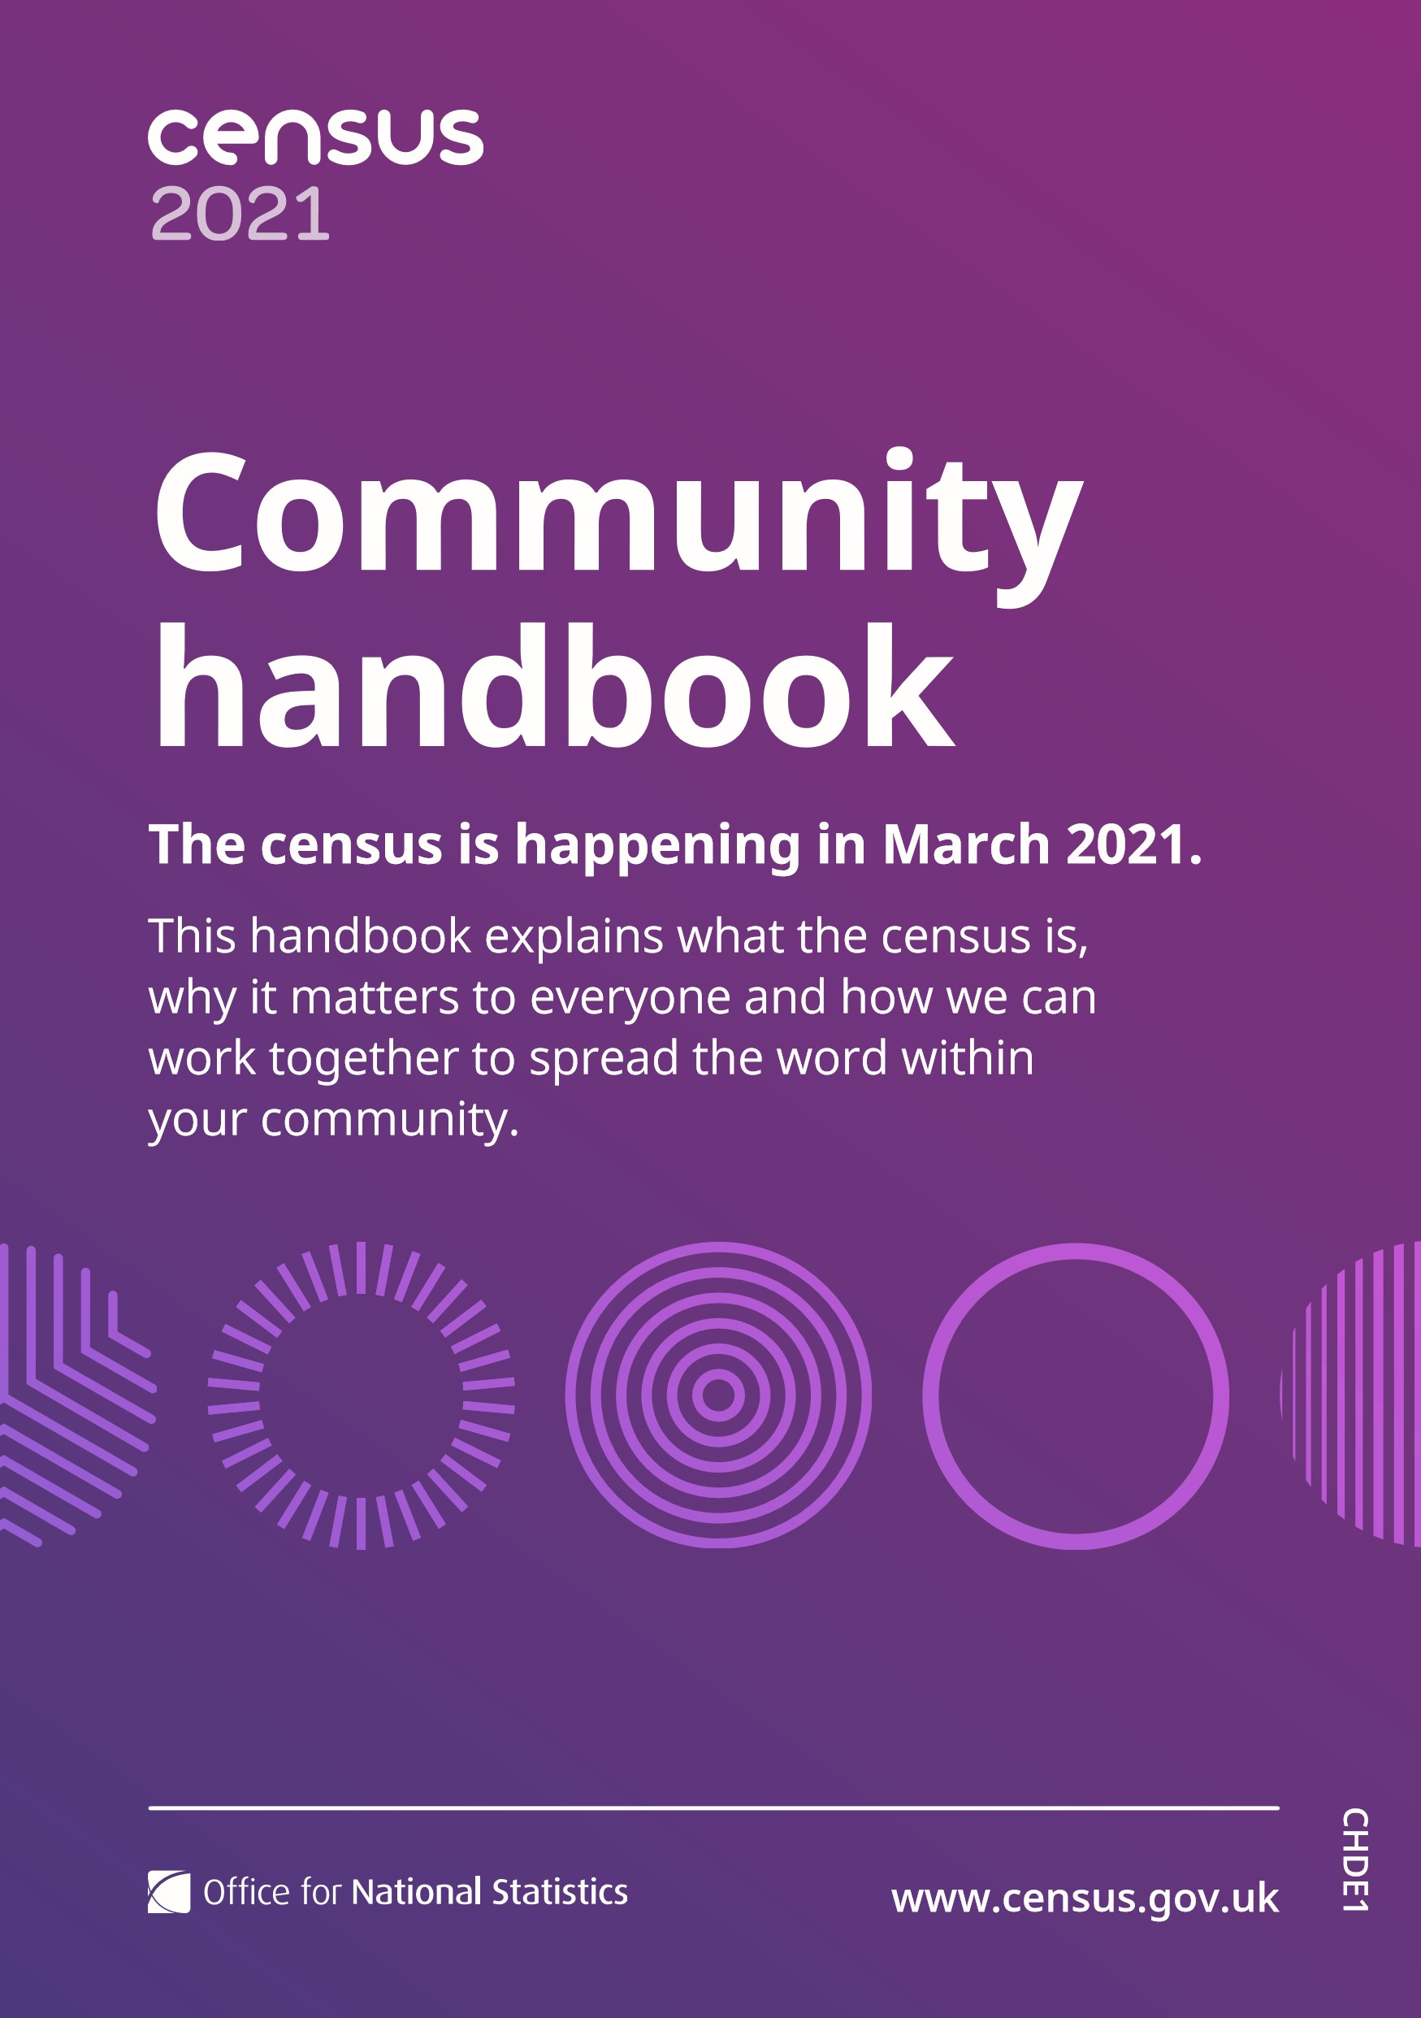
Contents

Message from ONS Census
Director of Operations 3
About the census 4
What is the census and why does it matter? 4
Who runs the census? 5
What does the census ask? 6
New questions to reflect the needs of society 7
Data protection and privacy 8
Making it easy to take part 9
An accessible census 9
Specialist support for communities 10
Local field staff 10
A wide-reaching marketing campaign 11
How we can work together 12
Census engagement managers 13
Building community links 14
Community toolkit 15
Useful information 16
Please note: The information in this document is correct at the time of writing. Should developments related to Covid-19 or other unforeseen circumstances require us to change our approach to Census 2021, we will endeavour to update you as they occur.
2

Dear reader
Welcome to your Census 2021 community handbook.
It explains what the census is and why it matters to everyone. It also gives information on the ways you can help make the census a success in your area and for your community.
The census is for everyone. Once every 10 years, it helps build the most complete picture of England and Wales. The whole population has the chance to provide the information that ensures all communities are represented in decisions on funding and services.
The census is so important that it’s compulsory for everyone in England and Wales to take part. We at the Office for National Statistics (ONS), are responsible for making it as easy as possible for everyone to join in.
We want to understand the needs of communities and organisations like local charities for Census 2021.
3
We’re working closely with your local council to co-ordinate census activities in your area that’ll help raise awareness and increase engagement. We’re also working closely with local community groups and charities. By working with you,
we can make sure we understand any challenges people in your community may face in taking part. This will allow us to plan support that helps everyone to take part.
Thank you for supporting the census – and for encouraging people in your community to take part in March 2021.

Peter Benton

Director of Census Operations
Office for National Statistics

About the census

What is the census and why does it matter?
The census is a survey that happens every 10 years and gives us a picture of all the people and households in England and Wales.
The census is unique. There’s simply nothing else that gives so much detail about us and the society we live in. It tells us what our needs are now, and what they’re likely to be in the future. It also gives a snapshot of how we live, for future generations to look back on.
Knowing what your community’s needs are helps organisations like councils plan and fund public services in your area and across England and Wales. Information you give informs where billions of pounds of funding is spent on things like transport, education and health.
Charities and voluntary organisations often use it as evidence to get funding. It helps businesses to understand us as customers and, for example, decide where to open new shops. Plus, those doing research, like university students and people looking into their family history, use the information.
Without the census – and without people in your community telling us about their household and home – it would be much more difficult to do this. That’s why it’s so important everyone takes part.
4
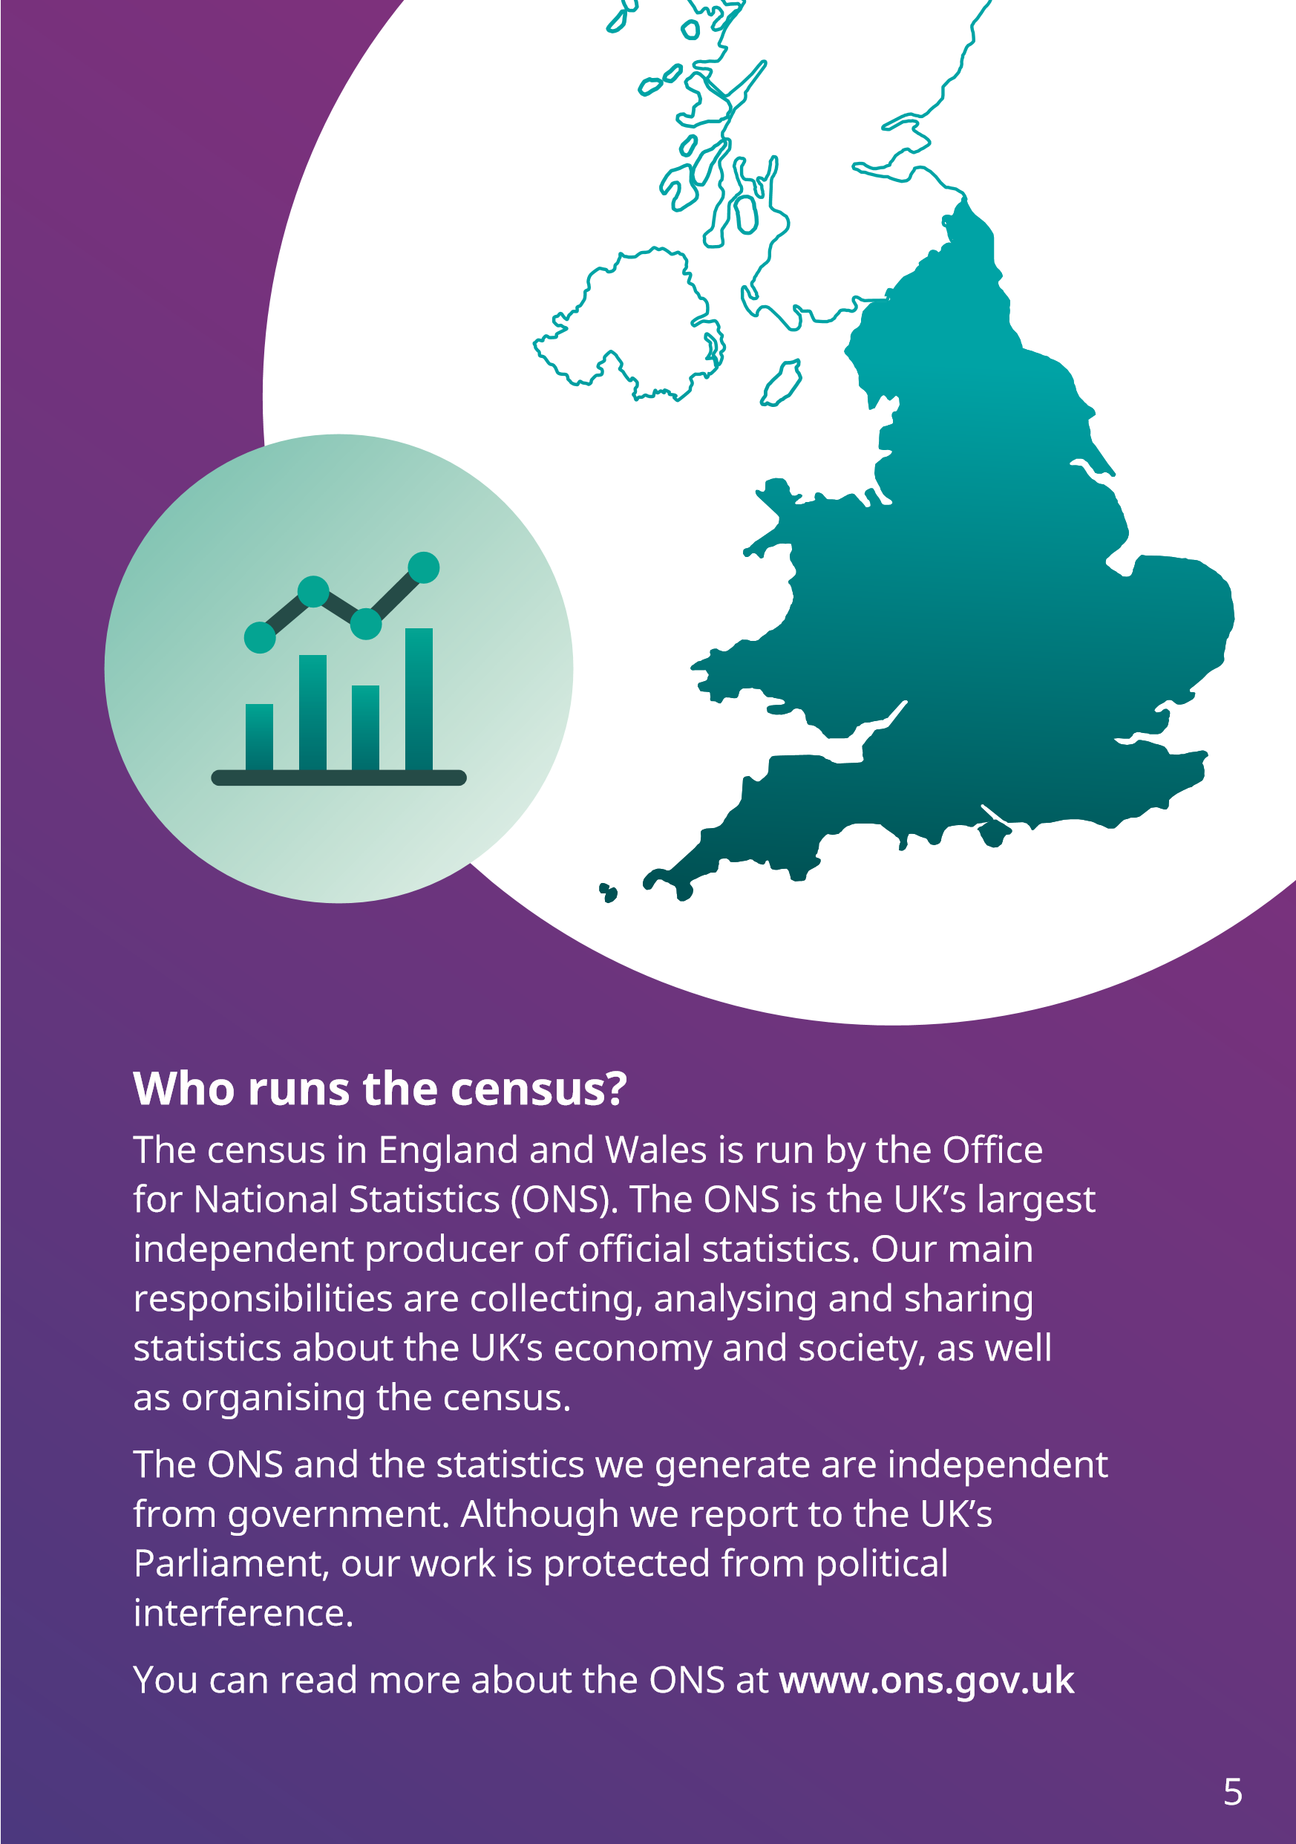

What does the census ask?
The information we collect during the census helps us to create an in-depth picture of our society. It’ll also identify important trends that’ll help organisations plan services and allocate funding in the future.
To achieve this, the census asks questions on a range of topics, including information about:
- individuals, such as their name, age, sex and marital status
- households, such as family relationships
- the homes we live in, such as their location, number of people living there and what facilities they have
It is up to individuals to decide how they would like to answer each question. For questions such as those about ethnicity, religion and nation identity, we actively encourage people to complete the questionnaire how they feel best represents them. We are engaging with community groups to ensure that everyone knows they are free to identify how they choose, and how to do so.
The ONS only ever publishes anonymous statistics from the census. We don’t publish anyone’s name. We only ask for them to help ensure the statistics are accurate, for example, to help us make sure that each person is only counted once.

New questions to reflect the needs of society
Following discussions with the public, testing and research, and after careful consideration, Census 2021 will ask questions on three new topics. These are:
- service in the UK Armed Forces
- gender identity
- sexual orientation
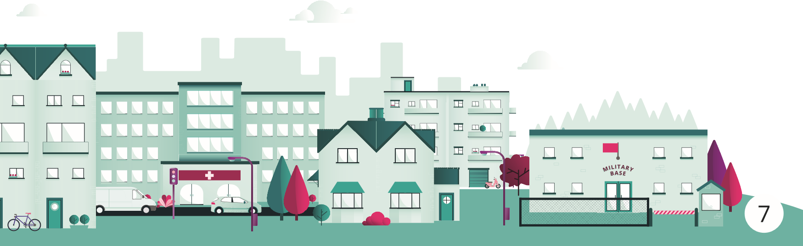
The UK Armed Forces question will gather information on past service in the UK Armed Forces. This is to help organisations support veterans in line with the Armed Forces Covenant – a promise between our country and those who have served it.
The questions on sexual orientation and gender identity will give us better information on lesbian, gay, bisexual and transgender populations. This’ll help organisations to combat any inequalities these groups may face and show where services are needed.
We’ll only ask people aged 16 years and over these questions. The sexual orientation and gender identity questions are also voluntary, so no one will be forced to answer if they do not want to. People can also request an individual census questionnaire and give their answers separately if they want to.
If you’d like more information about the census, visit www.census.gov.uk

Data protection and privacy
The safety of your information is our top priority.
The census asks questions about you, your home and the people who live in it. The census has a proud 200year history of keeping this personal information safe.
We have a strict security regime that follows government standards. This includes physical and IT security measures to protect your data, covering people, processes and technology.
What’s more, no one can tell who you are in the statistics we publish.
All our systems, staff and suppliers, and the way we do things must protect your confidentiality by law. It is a crime for anyone to share your personal information.
Government departments dealing with any applications you’ve made, or any payments or services you receive, cannot see your census information. For example, it cannot be used to influence benefit claims, a residency application, immigration status or taxes. Landlords, or any private organisation, will not be able to see your personal information either.
We’ll never use your personal information to try to sell you anything or find you. We’ll never sell your information.
Census records will be kept secure for 100 years. Only then can future generations view them, for example, those interested in family history.
8

Making it easy to take part
Everyone should have the support they need to take part in the census and we’ve made the questionnaire as simple as possible to complete. Most people will be able to do it themselves, but we know there are people who’ll need a little extra help.

An accessible census
Census 2021 will be “digital first” meaning it’ll be mainly online. We know there are people who’ll find this challenging. We’ll offer a wide range of support services to make sure the census is as accessible and inclusive as possible. These include:
- guidance and support in many languages and formats
- help in local centres with trained staff and online access
- a contact centre to give help over the phone, in a webchat, webform, email and SMS
- field staff contacting households that have not yet filled in their form
- accessible census questionnaires, for example, in Large Print
- the option to request paper questionnaires
We’ll also automatically issue paper questionnaires in areas where we’ve identified residents are highly likely to need them.
No one from the ONS or Census 2021 will ever ask for payment to help anyone to fill in their questionnaire.
9

Specialist support for communities
We’ve hired census engagement managers (CEMs) to work with local leaders, community organisations and charities. Their role is to build understanding of the census and help everyone take part.
Local engagement staff also work with CEMs to support communities with specific needs, for example, people who do not use English as their first language.
To find out more about the role of CEMs see page 13.

Local field staff
There’ll also be a large team of field staff on hand to help people across England and Wales. They’ll have local knowledge and be there to encourage and support people to fill in their questionnaires.
We want these field staff to reflect the local communities they serve, so we welcome applicants from all backgrounds and ages. People can find out more at www.censusjobs.co.uk

A wide-reaching marketing campaign
Our marketing campaign will raise awareness of the census. It’ll include adverts in newspapers, on television, radio and social media, as well as posters on buses and billboards. Some adverts will aim to reach everyone in England and Wales. We’ll tailor others to meet the needs of specific groups, such as students, older people, or people who may not speak English as their first language.
We’ll also be working with partners like schools and businesses to help spread the word and encourage support.

How we can work together
Knowledge
Your knowledge of the people in your community can help us put support in place that lets everyone take part.
Awareness
Your community links can help us spread the word about what the census is and why it’s so important. This will build trust in the census and encourage people to join in.
Access
Your networks can help us reach people in your community who need support filling in their census form. This will make sure they’re included and counted too.
12
We know that building positive relationships with communities and charities means more people will see the benefits of the census and decide to take part.
We also understand that no one knows your community better than you. We need your help to raise awareness of the census in your community and encourage people to fill in their questionnaire.

Census engagement managers
Census engagement managers (CEMs) help groups of people to take part in the census.
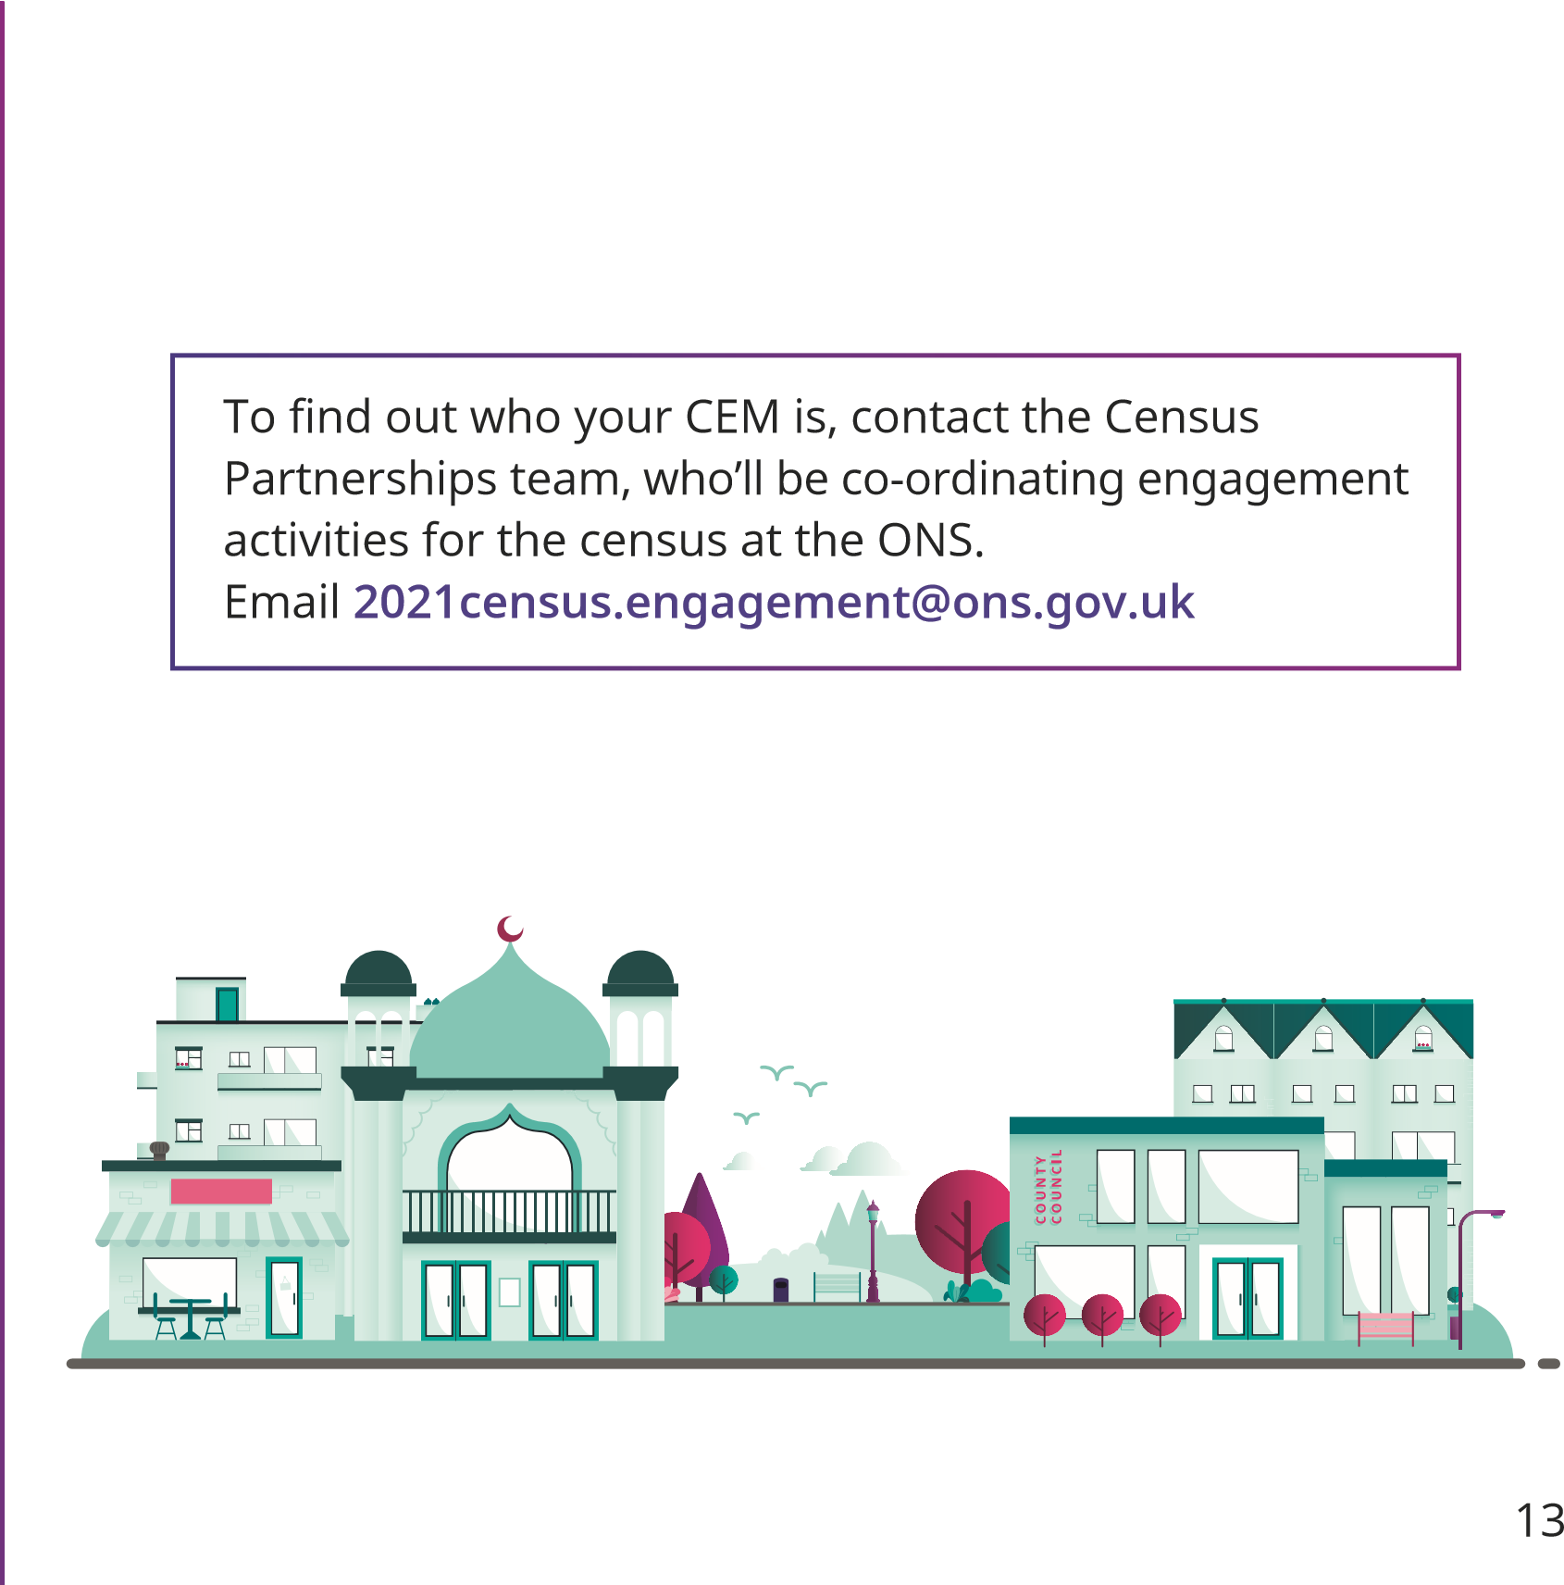
Their job is to build links with local community organisations, trusted local leaders and charities, so that more people can take part in the census. They do this by raising awareness, helping people understand why the census is important and building trust in the census. They give reassurance and practical support so that everyone can take part.
You can work with CEMs in many ways to help your community take part in Census 2021. There are a few examples on the next page.

Building community links
Your local census engagement manager would love to hear from you to learn more about your community and the ways in which they can help support you in Census 2021.
These are some of the questions they may ask you.
- Can you tell us how we could help make the census easier to complete for people in your area?
- Can you put us in touch with other local leaders and community representatives who’ll spread the word?
- Can you give examples of how census information has benefited your community?
- Can you host meetings where we introduce the census?
- Can you invite us to your community events?
- Can you advertise census jobs through your newsletters or social media?
- Can you provide space or technology for people wishing to fill in their census form with support?
Your CEM can also help you raise awareness of the census by:
- giving information, advice and support for your organisation/community
- supplying digital and printed resources, such as information leaflets, for you to share
- creating content for you to use, for example, in your newsletters or on social media
- creating and sharing case studies that promote your work and community
14
If you work for a local authority, we have a dedicated team to help you. Email them at 2021census.LA.liaison@ons.gov.uk
If you know someone who might like to work
for the census in your local area, send them to www.censusjobs.co.uk

Community toolkit
We’ve created an online toolkit with resources you can start using straight away to help your community. We’ll be adding more and more things to this as the census gets nearer.
You can access them at www.census.gov.uk/partners
Resources include, or will soon include:
- information to help you explain what the census is and why it matters
- ideas to help you and your CEM build support in your area
- content about the census for you to use in newsletters and on social media
- census job descriptions
- activities for children
Between now and March 2021, please do keep talking about how important the census is.
The Census Partnerships team is on hand at
2021census.engagement@ons.gov.uk if there’s anything you’d like to talk about.
We look forward to working with you to make Census 2021 a success.
15
